Festo: Simply reliable configuration
Festo Design Tool 3D for error-free configuration and ordering of pneumatic systems

Augsburg, Esslingen, Germany, 09th December 2014. Fast, reliable and efficient – the configuration software Festo Design Tool 3D reduces the risk of errors when designing and ordering system modules and offers greater convenience. The Festo Design Tool 3D was developed in cooperation with CADENAS the software manufacturer from Augsburg. Delivering system modules as a complete package with one order item simplifies logistics and assembly operations.

Until now, there was always a residual risk when dimensioning and ordering pneumatic drives. Many individual system components had to be placed manually by designers using CAD systems, and the result was long lists of items to be ordered. The potential for errors was therefore large.

More security

There is now an answer to this problem – the new Festo Design Tool 3D provides more security. Fast, reliable and efficient, this configuration software provides a convenient way of dimensioning standard cylinder modules with accessories in all the usual CAD formats.

The Festo Design Tool 3D for pneumatic systems genuinely reduces the amount of system design work and therefore saves a considerable amount of time. The risk of errors when compiling parts lists and ordering individual components is significantly lowered.

Fast installation, simple selection

This tool can be installed locally on the user's own computer in just a few steps and is then fully operational. The Festo Design Tool 3D not only allows the required pneumatic drive to be selected easily but also automatically places the chosen accessories on the cylinder in accordance with the user's needs.

All that system designers need to decide is whether they would like to receive a complete cylinder module pre-assembled in accordance with the client's needs or would rather have a so-called "PrePack" as part of a complete package. Finally, the modern CAD configuration software generates one order item in the Online Shop basket. By following this specific procedure with the Festo Design Tool 3D, users can avoid inadvertent errors in the type codes in parts lists and in the relationships between components in CAD drawings. This procedure also reduces the amount of work needed in all subsequent departments.

Saves time and work

Whether they are engineers, buyers, storekeepers or installation technicians, the new CAD configuration software Festo Design Tool 3D offers all users more security and reduces their workload. The simple graphic overview of accessories, the automatic error-free placing of accessories, the elimination of the need for individual downloads and the efficient way in which an order can be placed with one order item – all this minimises the risk of configuration errors and saves time all along the entire value chain.

The subsequent delivery as a single package makes project engineering simpler and also reduces packaging waste. Whether supplied pre-assembled or as a "PrePack", the installation of pneumatic drives with the Festo Design Tool 3D is secure and reliable.

The Festo Design Tool 3D is now available in 20 countries. Just click: www.Festo.com/FDT-3D

Press Images:

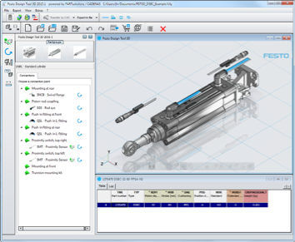
Caption: Fast, reliable and efficient – the configuration software Festo Design Tool 3D reduces the risk of errors when designing and ordering system modules and offers greater convenience. (Photo: Festo AG & Co. KG)

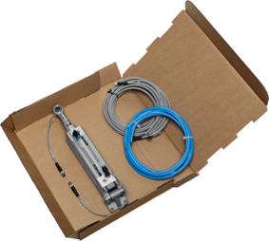

Caption: Users have the choice – a PrePack or a pre-assembled module. (Photo: Festo AG & Co. KG)

The press release and the images are available for download on our website: www.cadenas.de/press/press-releases

About CADENAS

CADENAS is a leading software developer in the areas of Strategic Parts Management and parts reduction (PARTsolutions), as well as Electronic Product Catalogs (eCATALOGsolutions). With its customized software solutions, the company acts as a link between the component manufacturers with their products and the purchasers.

With its 300 employees at 15 international subsidiaries, the name CADENAS (Hispanic: process chains) has been standing for success, creativity, support and process optimization since 1992.

For further information, please visit: www.cadenas.de/en

