Seamless integration of the 3D CAD download portal in the Wärtsilä website
Improved CAD download due to better PARTcommunity embedded technology

AUGSBURG, Germany 26th July 2013 – CADENAS presents its global innovation: The 3D CAD download portal technology PARTcommunity has been now seamlessly integrated – without programming effort, but with a customer specific design and layout – in the website of a component manufacturer. As of now, manufacturers of components can integrate any desired elements of the CADENAS PARTcommunity technology for 3D CAD download portals. These are, for instance, search for the desired component, product display or CAD download. Layout and design of the PARTcommunity embedded can be graphically designed via backend by yourself without programming experience.

Wärtsilä, a global leader in complete lifecycle power solutions for the marine and energy markets, is the first to adopt the next generation of the PARTcommunity embedded technology developed by the software manufacturer from Augsburg. All functions of the 3D CAD download portal PARTcommunity are seamlessly integrated into the website of the company headquartered in Helsinki. This allows an even faster and easier download of the 3D CAD models of marine engines.

Comprehensive 3D CAD model service directly on the manufacturer's website
Due to the new PARTcommunity embedded technology, Wärtsilä's customers can directly look for 3D CAD models of the marine engine series Wärtsilä 20, configure them or, for instance, have a 3D preview and a chart with all component information displayed. Afterward engineers can, for instance, download the 3D CAD models easily in a JT format or import them directly into their respective CAD system for shipbuilding and plant engineering like AVEVA Marine and Tribon. The extensive CAD service is easy to handle and can be operated intuitively.

Wärtsilä has an Electronic Product Catalog based on CADENAS' eCATALOGsolutions technology. Due to PARTcommunity emdedded, the know-how of the software manufacturer from Augsburg is directly integrated in the own website. The decisive benefit of the innovative technology is that users are not led away from the manufacturer's website because of popups or external links. A special programming by the manufacturer or CADENAS is not necessary in this case.

3D CAD models of the marine engine series Wärtsilä 20 are ready for download here.

Wärtsilä in brief:
Wärtsilä is a global leader in complete lifecycle power solutions for the marine and energy markets. By emphasising technological innovation and total efficiency, Wärtsilä maximises the environmental and economic performance of the vessels and power plants of its customers. In 2012, Wärtsilä's net sales totalled EUR 4.7 billion with approximately 18,900 employees. The company has operations in nearly 170 locations in 70 countries around the world. Wärtsilä is listed on the NASDAQ OMX Helsinki, Finland. www.wartsila.com

Press photo
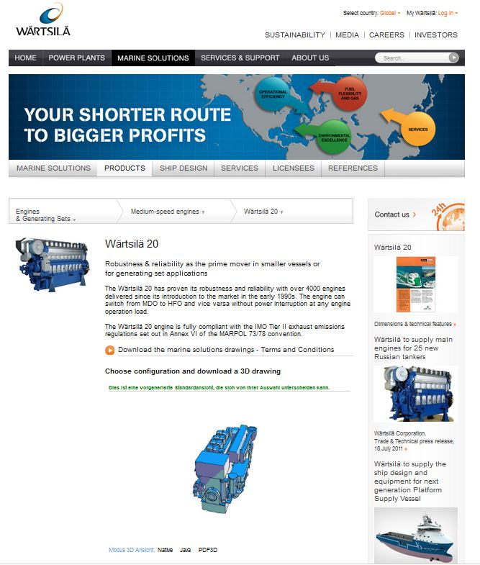

Caption: Wärtsilä, a global leader in complete lifecycle power solutions for the marine and energy markets, is the first to adopt the next generation of the PARTcommunity embedded technology developed by CADENAS

The press release and pictures are available for download on our website: www.cadenas.de/press/press-releases

About CADENAS

CADENAS is a leading software developer in the areas of Strategic Parts Management and parts reduction (PARTsolutions), as well as electronic product catalogs (eCATALOGsolutions). With its customized software solutions, the company acts as a link between the component manufacturers with their products and the purchasers.
With its 300 employees at 14 international subsidiaries, the name CADENAS (Hispanic: process chains) has been standing for success, creativity, support and process optimization since 1992.

In its role as initiator and pioneer, CADENAS has already established many important innovations and trends.

PARTsolutions innovations:
- The search for CAD parts using topologies
- The similarity search for CAD parts which runs automatically in the background
- The CAD parts search through sketching
eCATALOGsolutions innovations:
- Search for 3D CAD parts on smartphones
- Using 3D glasses to present CAD models
- Operating 3D CAD parts with a Wii controller
- Support of the Augmented Reality Technology
- ePRODUCTplacement: Offer the right part at the right time to the right person
For further information about our newest innovations, please visit our website: www.cadenas.de.

