PARTcommunity embedded Technology makes a seamless integration of the 3D CAD catalog possible for the first time

Technological innovation at PARTcommunity allows integrated download of 3D CAD models from the own website

AUGSBURG, Germany 26th August 2013 - GETOtec, the established solution provider for linear technology and mechanical engineering from Munich is one of the first customers to enjoy CADENAS’ PARTcommunity embedded technology. With this global innovation in the field of electronic product catalogs the complete 3D CAD download portal based on CADENAS eCATALOGsolutions technology was integrated into the website in the course of optimizing the web presence of GETOtec. Thus customers have direct access to all 3D CAD data of the product catalog.

This way, it is globally available at any time and engineers can define necessary parts exactly without additional effort, configure products, generate interactive 3D views and download the desired 3D CAD model directly and for free into the design space.

Individual design of the web presence due to embedded technology

While redesigning the website of GETOtec, among other things, the download area was completely revised and attuned to customer’s demands. Thanks to seamless technology, the complete product catalog appears in the corporate design of the manufacturer under the category “products”– with no need for complex programing. This way GETOtec was able to define certain elements themselves, for instance the 3D preview of parts, according to their demands and needs. Hence, the new web presence got a clearer user guidance which is more tuned to the target group.

On average the integrated solution of CADENAS‘ 3D CAD download portal PARTcommunity increases the number of potential downloads from the manufacturer’s product catalog by approx. 30 percent: The customer does not have to go to an external website to call up the CAD data, but finds all information on the product clearly arranged on the manufacturer’s website.

Professional redesign of the GETOtec website by CANVAS

The redesign of the website was carried out by the media agency CANVAS, a subsidiary wholly owned by CADENAS. In doing so the original system was completely reinstalled on the basis of the Contao Content Management Systems, which allows a more simple creation and maintenance of the contents. In the course of introducing the embedded technology it was suitable to offer the redesign as a practical additional contribution, although ,needless to say, the integration of the PARTcommunity technology is also possible without making changes to the existing system.

In the course of the reconstruction the offered information was also extended significantly: The product section received a better menu navigation with preview pictures, short information texts and the direct download of documents and CAD files of the single components.

Your product catalogs as integrated solution by CADENAS

The simplified access due to the PARTcommunity embedded solution and the improved download figures resulting from it, are available to every component manufacturer who has a catalog with the eCATALOGsolutions technology. For further information please visit embedded@cadenas.de.

Press photo
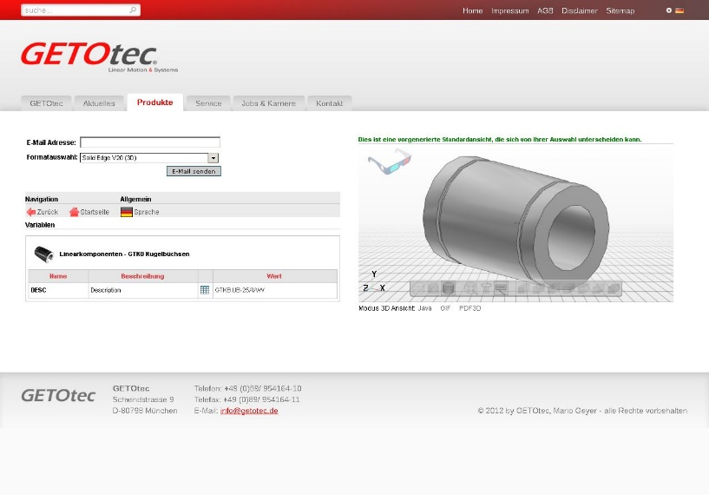

Caption: GETOtec, established solution provider for linear technology and mechanical engineering from Munich, is one of the first to adopt the next generation of the PARTcommunity embedded technology developed by CADENAS

The press release and pictures are available for download on our website: www.cadenas.de/press/press-releases

About CADENAS

CADENAS is a leading software developer in the areas of Strategic Parts Management and parts reduction (PARTsolutions), as well as electronic product catalogs (eCATALOGsolutions). With its customized software solutions, the company acts as a link between the component manufacturers with their products and the purchasers.
With its 300 employees at 14 international subsidiaries, the name CADENAS (Hispanic: process chains) has been standing for success, creativity, support and process optimization since 1992.

In its role as initiator and pioneer, CADENAS has already established many important innovations and trends.

eCATALOGsolutions innovations:
- Search for 3D CAD parts on smartphones
- Using 3D glasses to present CAD models
- Operating 3D CAD parts with a Wii controller
- Support of the Augmented Reality Technology
- ePRODUCTplacement: Offer the right part at the right time to the right person
For further information about our newest innovations, please visit our website: www.cadenas.de.

