Siemens and CADENAS Extend Partnership to Further Align STEM Education with Manufacturing Job Opportunities
Students and educators worldwide now have access to the same huge online catalog of 3D digital parts used to increase product design productivity for industrial manufacturers
PLANO, Texas, and Augsburg, Germany, December 3 2013 – Siemens’ product lifecycle management (PLM) software business unit and CADENAS have extended their partnership to provide students in science, technology, engineering and math (STEM) related fields, with free access to a popular product design productivity tool used by the global manufacturing industry. Siemens PLM Software’s academic partners – including students, researchers and educators – can now quickly and efficiently find and download standard parts from a massive digital database based on CADENAS’ widely-used PARTcommunity technology. By providing academia with the same technology used by many companies in the global manufacturing industry to instantly access millions of 3D parts from more than 400 manufacturers, Siemens and CADENAS are helping to further align STEM education with real-world job opportunities.
“Our academic program is focused on developing a highly trained and heavily recruited PLM workforce,” said Bill Boswell, senior director of Partner Strategy, Siemens PLM Software. “Student engineers and computer scientists who work with real-world data like this can be stronger graduates. In addition, they can save time and increase their productivity using standard parts – just like our customers do every day.”
When manufacturing companies design new products, many of the parts they use are standard designs available from several sources. However, if these standard parts are difficult and time consuming to locate and identify, time is wasted searching through catalogs, or possibly even creating a new design for a part that already exists. As a result, for the past several years, manufacturers worldwide have used tools like CADENAS PARTsolutions to quickly locate and use standard parts so they can spend more time on adding value to their product designs. This agreement makes this same level of product design productivity available to engineering students worldwide at no cost. Through geometric similarity searches, intelligent search systems and access to sensibly structured catalog data, the online catalog exposes students to concepts of mass customization and CAD model reuse, both of which are keys to productivity for future employers.
“Engineering excellence can only be achieved with practical orientation,” said Jürgen Heimbach, CEO of CADENAS. ”Students are now able to use the same resources as the industry pros.”
The CADENAS catalog supports all of the 3D data formats relevant to the global manufacturing industry, including those associated with Siemens’ NX™ software, Solid Edge® software and the JT™ data format. For more information visit: siemensacademic.partcommunity.com/

Press Photo
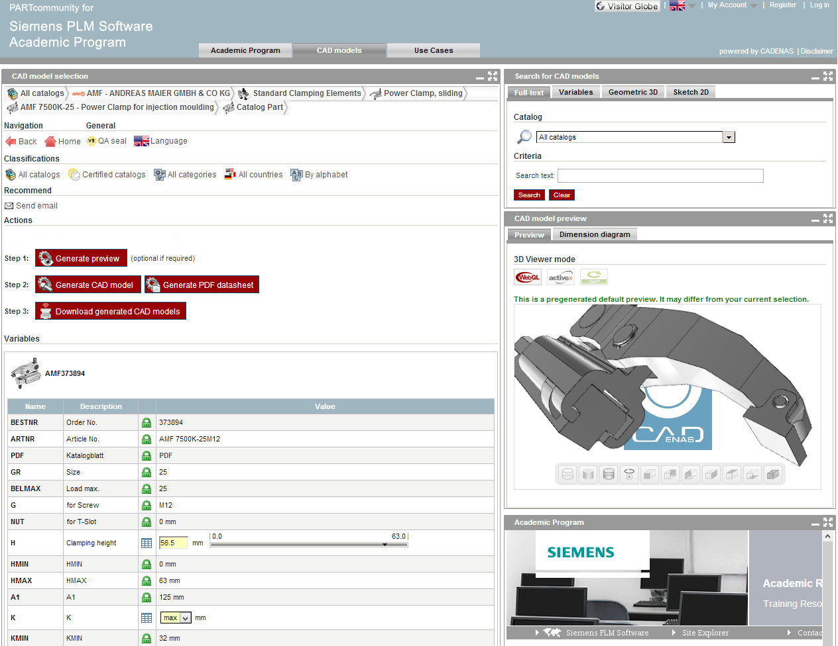
Caption: With the Siemens PLM Software Academic Program, Students worldwide have gratis access to millions of parts in 2D & 3D CAD formats from over 400 catalogs of well-known manufacturers.

About CADENAS GmbH
CADENAS is a leading software developer in the areas of Strategic Parts Management and parts reduction (PARTsolutions), as well as Electronic Product Catalogs (eCATALOGsolutions). With its customized software solutions, the company acts as a link between the component manufacturers with their products and the purchasers.

With its 300 employees at 14 international subsidiaries, the name CADENAS (Hispanic: process chains) has been standing for success, creativity, support and process optimization since 1992.

In its role as initiator and mastermind, CADENAS has already established many innovations and trends.

eCATALOGsolutions innovations:

Search for 3D CAD parts on smartphones
Using 3D glasses to present CAD models
Operating 3D CAD parts with a Wii controller
Support of the Augmented Reality Technology
ePRODUCTplacement: Offer the right part at the right time to the right person

For further information about our newest innovations and the company, please visit our website at: www.cadenas.de/en.

About Siemens PLM Software
Siemens PLM Software, a business unit of the Siemens Industry Automation Division, is a leading global provider of product lifecycle management (PLM) software and services with seven million licensed seats and more than 71,000 customers worldwide. Headquartered in Plano, Texas, Siemens PLM Software works collaboratively with companies, delivering open solutions to help them make smarter decisions that result in better products. For more information on Siemens PLM Software products and services, visit www.siemens.com/plm.

About Siemens Industry Automation Division
The Siemens Industry Automation Division (Nuremberg, Germany) supports the entire value chain of its industrial customers – from product design to production and services – with an unmatched combination of automation technology, industrial control technology, and industrial software. With its software solutions, the Division can shorten the time-to-market of new products by up to 50 percent. Industry Automation comprises five Business Units: Industrial Automation Systems, Control Components and Systems Engineering, Sensors and Communications, Siemens PLM Software, and Water Technologies. For more information, visit www.siemens.com/industryautomation.
# # #
Note: Siemens and the Siemens logo are registered trademarks of Siemens AG. NX, Solid Edge and JT are trademarks or registered trademarks of Siemens Product Lifecycle Management Software Inc. or its subsidiaries in the United States and in other countries. All other trademarks, registered trademarks or service marks belong to their respective holders.

