Sell technical products faster and easier, due to partnership with Sunglass
Work with component suppliers collaboratively on designs across the globe

Augsburg, Germany – July 2013. The American provider of the website www.sunglass.io partners exclusively CADENAS to offer component manufacturers and their industrial customers a high-level service for 3D CAD models.

Among other things it is the aim of www.sunglass.io to provide component manufacturers and their customers with a web-based platform, to collaboratively and globally develop and design products as well as engines through the web at the same time. This way www.sunglass.io offers component manufacturers the exclusive opportunity to make sales even more successful and further improve consulting of existing customers.

See how component manufacturers can further optimize their sales process in this short video:

http://www.youtube.com/watch?feature=player_embedded&v=AnBTRX8d5W4

Simply work on designs collaboratively with customers across the globe

Through the partnership between the software developer CADENAS of Augsburg and Sunglass, there are 1 million 3D CAD models from over 400 top-tier, international component manufacturers’ catalogs available on the web-based platform. On www.sunglasses.io, buyers of components can now directly search for the desired CAD models, select them and simply integrate them into their design within the Sunglass environment. It is possible to collaborate with the respective manufacturer on a design at the same time, to find the best solution for integrating a component.

Best support and expert consulting

Many components are very complex and require comprehensive consulting from the respective manufacturer. By means of the web-based platform Sunglass, engineers no longer have to coordinate in conference calls or personally in meetings. This was often difficult to handle, since the engineering of many companies is globally positioned, spread across several continents. As of now, component manufacturers and buyers can collaborate through the web on a design in a fast and easy way. This ensures a comprehensive and prompt customer support. In many cases the collaborative exchange via web can replace a personal visit of sales staff at the customer's, which saves time and money.

Far more than just 3D CAD models

Moreover, component suppliers obtain all the high-quality information on a part within the Sunglass design workspace. These are, for instance, a 3D preview and information on the kinematics, color and texture of a part.

Designs that are collaboratively created in the web on www.sunglass.io, can afterwards be imported locally in a fast and easy way into the respective CAD system. This ensures a seamless transition in the developing process.

”We are thrilled that our 400 catalogs of 3D CAD models are now integrated into the interactive web-based platform of Sunglass“, said CADENAS CEO Jürgen Heimbach. “Sunglass provides the ideal platform for millions of component manufacturers and suppliers from 199 countries, to collaboratively work on designs. We truly believe that the 3D CAD model service on www.sunglass.io will exponentially increase the number of manufactured designs and components that are installed as a result.”

Press picture
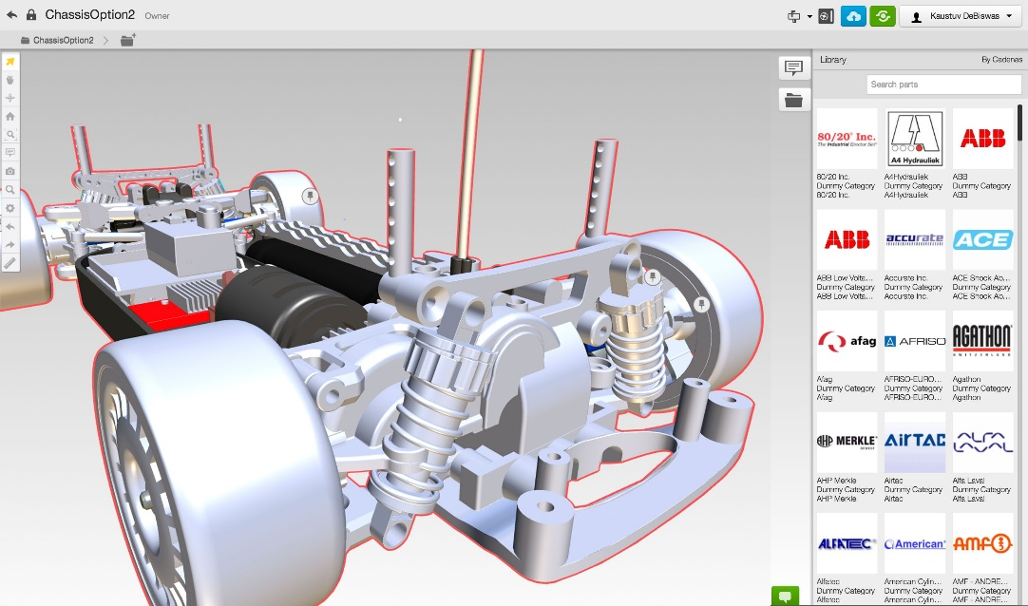

Caption: The web-based platform Sunglass offers access to over one million 3D CAD models based on eCATALOGsolutions Technology by CADENAS

The press release and pictures are available for download on our website: www.cadenas.de/press/press-releases

About CADENAS

CADENAS is a leading software developer in the areas of Strategic Parts Management and parts reduction (PARTsolutions), as well as electronic product catalogs (eCATALOGsolutions). With its customized software solutions, the company acts as a link between the component manufacturers with their products and the purchasers.
With its 300 employees at 14 international subsidiaries, the name CADENAS (Hispanic: process chains) has been standing for success, creativity, support and process optimization for 19 years.

In its role as initiator and pioneer, CADENAS has already established many important innovations and trends.

PARTsolutions innovations:
- Topology search for CAD parts
- Similarity search for CAD parts starts automatically in the background
- Search CAD parts by sketching

eCATALOGsolutions innovations:
- Search for 3D CAD parts on smartphones
- Using 3D glasses to present CAD models
- Operating 3D CAD parts with a Wii controller
- Support of the Augmented Reality Technology
- ePRODUCTplacement: Offer the right part at the right time to the right person
For further information about our newest innovations, please visit our website: www.cadenas.de.

