China's most important CAD software manufacturer CAXA relies on CADENAS PARTcommunity
Simple and fast access to millions of 3D CAD models for Chinese developers
AUGSBURG, Germany March 21st 2014 – CADENAS and CAXA present the new PARTcommunity portal which was especially adjusted for CAXA, offering one of the biggest collection of online catalogs for CAD models in native formats for the Chinese design software CAXA 3D. Via the Community portal, designers get immediate access to certified, native 3D CAD models from over 400 industrial manufacturer catalogs they can configure and download for free. These catalogs contain among others manufacturers like Festo, SMC, Airtac, CKD, NSK, SKF, ABB, Schneider, etc., covering the product fields pneumatics, hydraulics, casting, industrial electrical equipment, clamping technology, bearings, flange, and many other industrial products.
Visit the portal under: http://CAXA.partcommunity.com/
With the market launch of the PARTcommunity portal for CAXA 3D excellent tools and means are now at the disposal of CAXA customers making work a lot easier and supporting development: engineers can precisely browse manufacturer catalogs for the required parts, configure parameters at discretion, get an interactive 3D preview and– after registration – download the model in the desired 2D or 3D format for free, to inset it into their CAXA 3D environment. Especially user friendly are the integrated, innovative tools for full-text, variable, 2D sketch and 3D geometry search helping to find the required parts as quickly as possible.

Mr. Weiming Yang, CAXA marketing manager says: “CADENAS is one of the most important developers in the part management and part download service sector worldwide. CAXA is the biggest CAD and PLM software company in China and also operating internationally. Releasing the CAXA PARTcommunity is a great win-win situation for both companies“

“We optimize workflows with our solution and ensure a considerable increase in efficiency for developers and designers, while manufacturers of components get the possibility to grant millions of Chinese designers access to their products“, says Walter Leder, COO at CADENAS. “The most important being user-friendly and customer satisfaction. We share this philosophy with CAXA and are looking forward to continuing cooperation with the CAXA CAD team to offer engineers the most efficient solutions everywhere.“

Besides the online engineering portal, CADENAS will continue to closely cooperate with CAXA and develop additional complementary solutions.

“The portal is just a first step, we will deepen our integration in the future and are looking forward to a long-term cooperation with CADENAS“, says Weiming Yang, Deputy CEO CAXA.
Press Image:
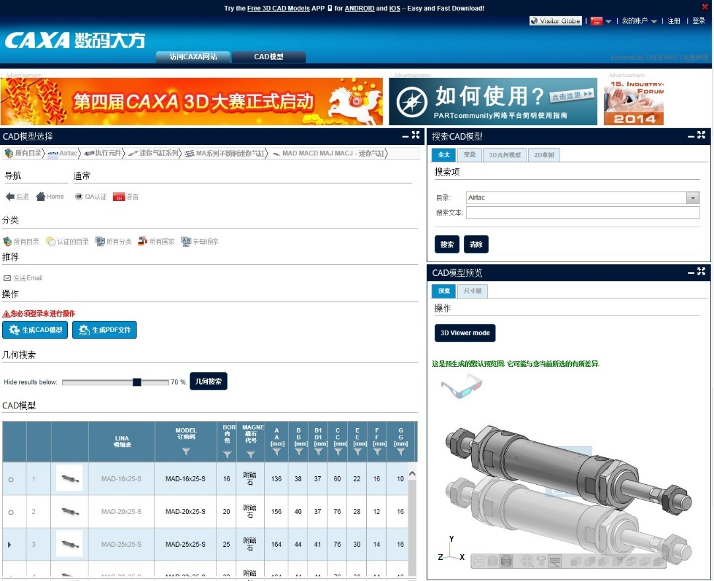
Caption: Via the Community portal designers get immediate access to millions of 3D CAD models they can configure and download for free.
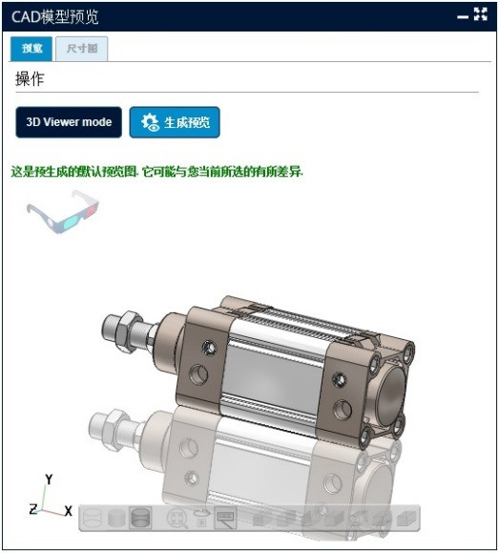
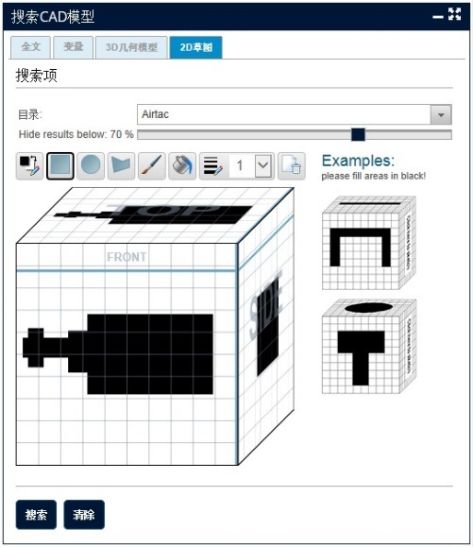

About CADENAS

CADENAS is a leading software developer in the areas of Strategic Parts Management and parts reduction (PARTsolutions), as well as electronic product catalogs (eCATALOGsolutions). With its customized software solutions, the company acts as a link between the component manufacturers with their products and the purchasers.

With its 300 employees at 14 international subsidiaries, the name CADENAS (Hispanic: process chains) has been standing for success, creativity, support and process optimization for 19 years.

In its role as initiator and pioneer CADENAS has already established many important innovations and trends.

PARTsolutions Innovations:
Search for CAD components with the topology search
The similarity search for CAD components starts automatically in the background
The CAD part search by sketching
The unmachined part search and cloud navigator search

eCATALOGsolutions Innovationen:
The 3D CAD model app
Using 3D glasses to present CAD models
Support of the Augmented Reality technology
The Smart Catalog – the print catalog becomes digital
ePRODUCTplacement: Offer the right part at the right time to the right person
Engineering knowledge database

For further information, please visit: www.cadenas.de

