A world first: Sketch search in the latest version of the PARTcommunity 3D CAD models app
The new PARTcommunity app version of CADENAS allows now faster product search through sketch drawing
AUGSBURG, Germany July 24th 2014 – The PARTcommunity 3D CAD models app by CADENAS is now available in the latest version 3.0.4. Besides many other optimizations in function and design, the popular, over 450.000 times downloaded app now possesses the trendsetting sketch search.

A Picture says more than a thousand words
Smartphone and tablet users with their relatively small screens and without real keyboard and mouse need a as simple as possible control interface. Especially in searches, typos can be extremely frustrating - even more so if there are special characters or case sensitivity. The latest version of the PARTcommunity 3D CAD models app has therefore been enhanced with a vital new element:

Through the "Sketch Search" called function, users of the popular app can now find parts not only through full text search or catalog browsing, but also through a simple sketch of the needed object. The interface is as simple as it is intuitive: Just trace the rough form of the object on the three sides of a cube and hit 'search'. If you want more detail, you can use various editing tools to refine the sketch and to narrow down the search results.

Intelligent interface meets clever communications
Also, the app's look&feel has been further improved. With the transition to flat design, the application now shows a much tidier look and provides an even more comfortable user experience - particularly on small smartphone screens. Another comfort function are the new sharing buttons. With those, selected content can now be shared with friends and colleagues not only by e-mail, but also through installed social media channels like Facebook, Google+ or Twitter.

Native app for Android and iOS
The PARTcommunity 3D CAD models app was developed and optimized specifically for both Android and Apple's iOS operating system. With it, engineers and purchasing agents in the sectors of machinery and equipment construction, as well as automotive have direct access to catalogs of more than 400 popular manufacturers with millions of components, which can be viewed as 2D or 3D models on smartpone or tablet. Additionaly, those CAD models can be downloaded and integrated in your own design environment in over 85 different CAD formats.

More Information on the PARTcommunity 3D CAD models app by cadenas can be found here: www.cadenas.de/en/app-store. If you have questions regarding function and applicability write us at Marketing@cadenas.de.

Press Image:
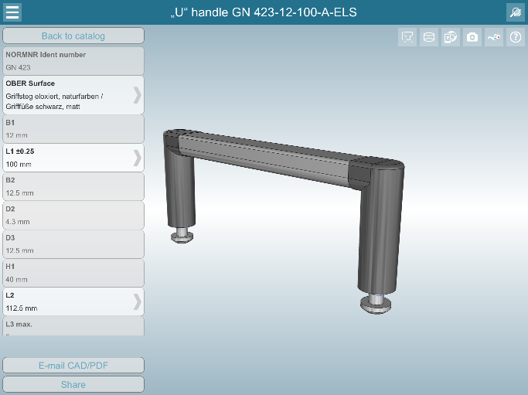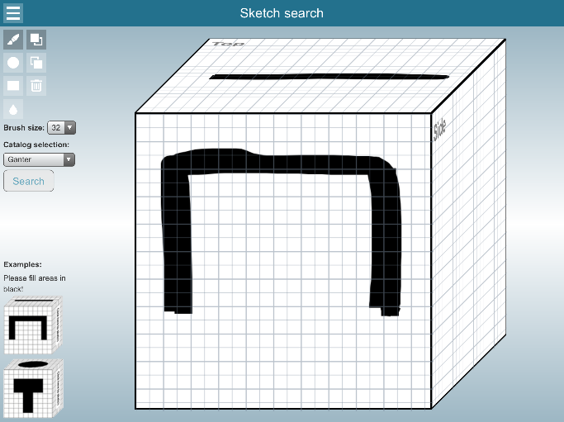
Caption: Through the "Sketch Search" called function, users of the popular app can now find parts not only through full text search or catalog browsing, but also through a simple sketch of the needed object.

About CADENAS

CADENAS is a leading software developer in the areas of Strategic Parts Management and parts reduction (PARTsolutions), as well as electronic product catalogs (eCATALOGsolutions). With its customized software solutions, the company acts as a link between the component manufacturers with their products and the purchasers.

With its 300 employees at 14 international subsidiaries, the name CADENAS (Hispanic: process chains) has been standing for success, creativity, support and process optimization for 19 years.

In its role as initiator and pioneer CADENAS has already established many important innovations and trends.

PARTsolutions Innovations:
Search for CAD components with the topology search
The similarity search for CAD components starts automatically in the background
The CAD part search by sketching
The unmachined part search and cloud navigator search

eCATALOGsolutions Innovationen:
The 3D CAD model app
Using 3D glasses to present CAD models
Support of the Augmented Reality technology
The Smart Catalog – the print catalog becomes digital
ePRODUCTplacement: Offer the right part at the right time to the right person
Engineering knowledge database

For further information, please visit: www.cadenas.de

