# PARTsolutions kicks into gear with version 9.8 CADENAS’ Strategic Parts Management accelerates workflows with improvements of GEOsearch, the full-text search and the new AppServer

**AUGSBURG, Germany, September 9th 2014** – CADENAS, software developer from Augsburg, Germany, released the latest version of the Strategic Parts Management PARTsolutions. Version 9.8 is characterized by more speed and better performance. Highlights are the accelerated intelligent finding functions based on the Geometric Similarity Search GEOsearch, the 2D Sketch-, Topology- and Full-text Search as well as the simplified remote access with a central hosting on the new Application Server web service.

**The highlights: more information and quicker results**

The new version offers numerous improvements for users:

The new PARTsolutions Application Server supplements the central data storage of the catalogs at one site. Moreover, the previous search server was integrated into the new AppServer, which means the administration only has to wait through one server process. Also a much faster use of the software and catalogs is now possible at sites with slower network connections.

The new auto-completion accelerates the Full-text Search up to 50 percent by showing the possible options during entry. Thus the Full-Text search can be handled as simply as the familiar and popular Google Search.

The new search filter assistant allows the user to quickly create search templates for certain part types such as bearings, screws, etc. with individual search criteria for several parts with unified variables.

The Geometric Similarity Search (3D), the Sketch Search (2D) and the Topology search also stand out with a performance improved of factor 10. Thus users can search 6.5 million parts within 3 seconds and compare them to all available supplier parts of the installed catalogs. It is also possible to quickly draw up an analysis whether a supplier part could be used instead of an expensive in-house production. On average, supplier parts cost 93 % less than internal parts and cause less storage costs. In consequence this new functions offers big saving potentials.

Numerous further improvements were made on these features. For instance, many new export Formats and Interfaces for CAD and PLM programs were added. For details and further information about the Strategic Parts Management PARTsolutions, please visit: www.cadenas.de/strategic-partsmanagement

**Press Image:**

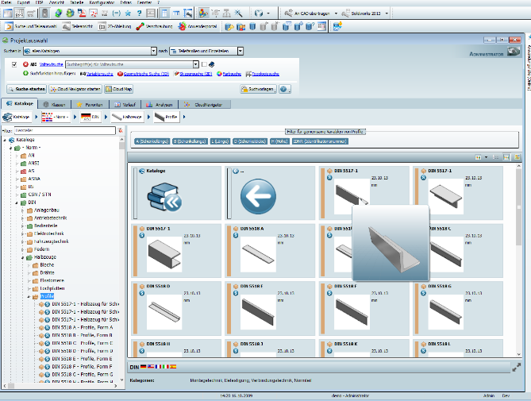

**Caption 1:** The Strategic Parts Management PARTsolutions version 9.8 is characterized by more speed and performance.

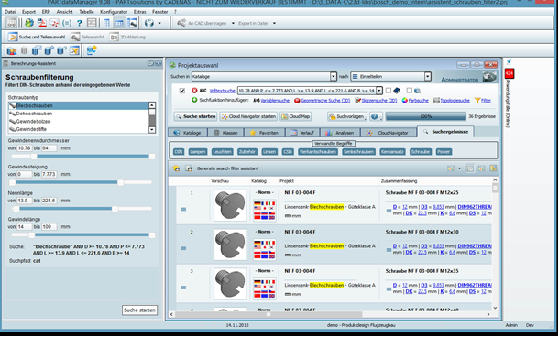

**Caption 2:** The new PARTsolutions Application Server supplements the central data storage of the catalogs at one site.

**About CADENAS**

CADENAS is a leading software developer in the areas of Strategic Parts Management and parts reduction (PARTsolutions), as well as Electronic Product Catalogs (eCATALOGsolutions). With its customized software solutions, the company acts as a link between the component manufacturers with their products and the purchasers.

With its 300 employees at 14 international subsidiaries, the name CADENAS (Hispanic: process chains) has been standing for success, creativity, support and process optimization since 1992.

In its role as initiator and pioneer CADENAS has already established many important innovations and trends.

**PARTsolutions Innovations:**

* Search for CAD components with the Topology Search
* The similarity search for CAD components starts automatically in the background
* The CAD part search by sketching
* The unmachined part search and cloud navigator search

For further information, please visit: www.cadenas.de/en