Successful 3D CAD download portal gets augmented with new 3D printing and 3D models sharing function PARTcloud
Share your own constructions with friends and colleagues and profit from the experiences of other engineers
AUGSBURG, Germany, September 18th 2014 – For years, the 3D CAD download portal PARTcommunity by CADENAS has been a top address for engineers looking for 3D CAD models of components. Every month, www.partcommunity.com registers over 8 million downloads of CAD models of well known, international manufacturers. PARTcommunity has now been augmented with the new PARTcloud function: With this innovative tool, engineers can also upload 3D CAD models of their self-constructed components and share them with friends and coworkers as well as make them available for download.

With the new PARTcloud function, PARTcommunity completes its range and provides a comprehensive service around everything about 3D CAD models. Through this, the research platform by CADENAS combines free downloads of millions of 3D CAD models with additional product information like PDF product catalogs, as well as the new PARTcloud function.

The 3D sharing platform PARTcommunity allows its users to determine themselves, which persons are allowed to see their content and who may download it.

PARTcommunity research platform provides unique possibilities

1. Experience CAD models in 3D
Users can experience uploaded 3D CAD models with red-cyan glasses in realistic 3D.

2. Leap Motion
With Leap Motion devices (www.leapmotion.com/product) comes action into play: The 3D CAD models can be turned and moved freely in space with your own hands.

3. Geometric Similarity Search
To find your own fitting parts or those of a friend or coworker fast and simple, the research platform provides comprehensive search methods like Geometric Similarity Search or a Search by Sketch function. This way, parts can be found and compared easily by their CAD geometry.

4. CAD models in numerous different CAD formats
The upload of your own 3D CAD models in STL or STEP format is child's play. Afterwards, the uploaded models are available for download in numerous other CAD formats.

Register free of charge and test the 3D printing and 3D sharing community today at: http://b2b.partcommunity.com/community/partcloud

If you take start now, you have the chance to win the PARTcloud Challenge and one of three Amazon gift certifcates with a total worth of 120 Euro: b2b.partcommunity.com/partcloud-launch

The B2B research platform PARTcommunity by CADENAS can be found at:
www.partcommunity.com

Press Image:

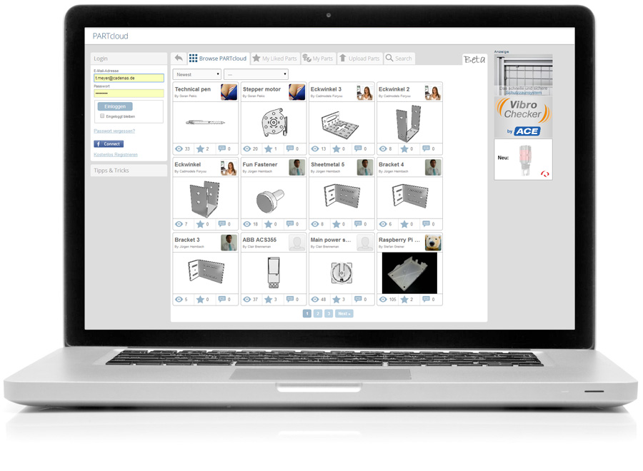
Caption: The new 3D printing and 3D models sharing function PARTcloud by CADENAS allows engineers to upload 3D CAD models of their self-constructed components and share them with friends and coworkers as well as make them available for download.
About CADENAS

CADENAS is a leading software developer in the areas of Strategic Parts Management and parts reduction (PARTsolutions), as well as Electronic Product Catalogs (eCATALOGsolutions). With its customized software solutions, the company acts as a link between the component manufacturers with their products and the purchasers.

With its 300 employees at 14 international subsidiaries, the name CADENAS (Hispanic: process chains) has been standing for success, creativity, support and process optimization since 1992.

For further information, please visit: www.cadenas.de/en

