**Strategic Parts Management goes mobile**

As of now PARTsolutions is available on smartphone and tablet

**Augsburg, Germany, 24th April 2015.** Since the beginning of April 2015, a mobile app version of CADENAS Strategic Parts Management PARTsolutions is available to users. With this new app, it is possible to visualize the PARTsolutions system environment on a smartphone or tablet. Thus, it is the first and only app that makes self-designed, standard and supplier parts combined with ERP and CAD data available for mobile devices.

**Find components in an easy way**

The Strategic Parts Management PARTsolutions has been effectively supporting engineers and purchasers for a long time in finding standard, supplier and self-designed parts in the company in an intelligent way, reducing them, avoiding duplicate copies and thus saving costs.

To have PARTsolutions at hand also in meetings, CADENAS new app offers a great amount of new features:

With the PARTsolutions app the planning phase for products also gets easier. Already during project-planning meetings, engineers can look for suitable parts on the tablet or smartphone. Finding components becomes very fast and simple: the app has extensive intelligent search methods, like the Geometric Similarity Search or the search with a 2D sketch. Components can be found and compared with each other very quickly and easily with CAD geometry. For this, respective self-designed, standard and supplier parts are shown in a 3D preview.

Moreover, users can also call up ERP information such as price, availability, etc. from systems like SAP.

The mobile access of the PARTsolutions app to data of the company’s own parts management is enabled by using the PARTapplication server for apps.

The new PARTsolutions app is available for the operating systems AndroidTM and iOSTM and can be downloaded from the Apple App Store and the Google Play Store:

PARTsolutions App for AndroidTM

<https://play.google.com/store/apps/details?id=de.cadenas.partsolutions>

PARTsolutions App for iOSTM

<https://itunes.apple.com/us/app/partsolutions/id929971034?mt=8>

**Press Images:**



**Caption:** A mobile app version of CADENAS Strategic Parts Management PARTsolutions is available to users.

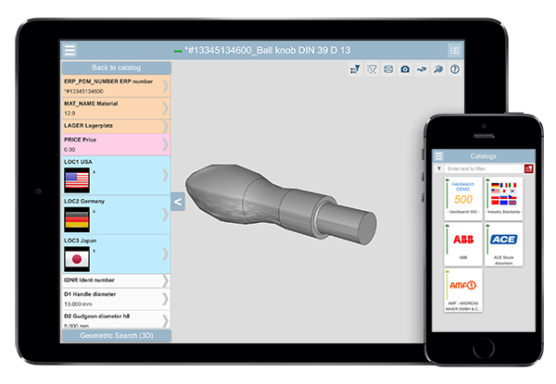

**Caption:** The PARTsolutions app makes self-designed, standard and supplier parts combined with ERP and CAD data available for mobile devices.

The press release and the images are available for download on our website: www.cadenas.de/press/press-releases

**About CADENAS**

CADENAS is a leading software developer in the areas of Strategic Parts Management and parts reduction (PARTsolutions), as well as Electronic Product Catalogs (eCATALOGsolutions). With its customized software solutions, the company acts as a link between the component manufacturers with their products and the purchasers.

With its 300 employees at 15 international subsidiaries, the name CADENAS (Hispanic: process chains) has been standing for success, creativity, support and process optimization since 1992.

For further information, please visit: www.cadenas.de/en