Fast and efficient design with HellermannTyton 3D CAD models
Download of 3D CAD models has been seamlessly integrated into the company website

Augsburg, Germany, 2nd June 2015. In cooperation with CADENAS, HellermannTyton is providing the 3D and 2D CAD data of thousands of its products for free download.

HellermannTyton is one of the leading global manufacturers and suppliers of products for fastening, fixing, marking, protecting and processing cables and wires. By implementing this CADENAS service, the company has made it especially easy for engineers to find cable management solutions and then import the respective CAD models of these products directly into their design. The Electronic Product Catalog based on CADENAS’ eCATALOGsolutions technology makes this possible. It currently includes HellermannTyton cable ties and fixings and cable protection products.

Seamless integration of 3D CAD download in product search results
Under the “Products” tab on the www.hellermanntyton.com website, engineers can now view the 3D CAD models of numerous products and download them. This service is featured in the search results alongside links to supplier sources and the respective catalog page for each product. The respective 3D CAD model and its preview are shown to the user in the internet browser via the PARTcommunity 3D web viewer. CADENAS’ PARTcommunity embedded technology has been enabling direct integration of the 3D CAD download into the company websites of component manufacturers since the middle of 2014.

HellermannTyton’s PARTcommunity download portal
HellermannTyton 3D CAD models are also available via their dedicated PARTcommunity download portal. Engineers can browse for parts in the catalog structure or discover them using the full-text search under http://hellermanntyton.partcommunity.com.

Afterwards, the CAD data of the desired product can be downloaded in all established formats and imported into the CAD system, or sent via email. Moreover, a PDF data sheet providing precise product dimensions, materials, product properties and the scope of delivery is available.

“The results of our comprehensive 2D and 3D CAD service are enormous time savings and optimal support during the design phase. This in turn leads to significant cost savings for our customers and prospects“, says James Hill, Communication Manager at HellermannTyton. “We are pleased with the take-up of the service and are extending the products in the database step by step“.

Press Images:

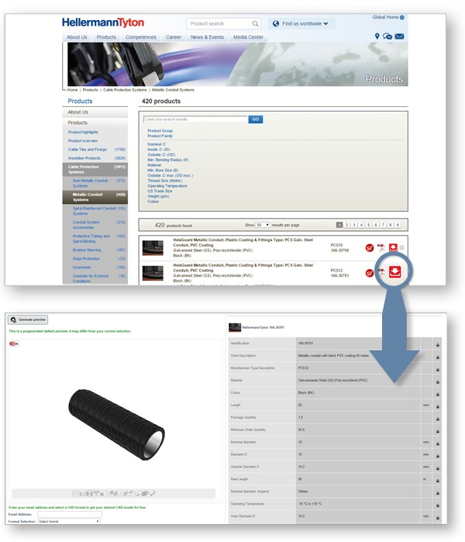
Caption: In cooperation with CADENAS, HellermannTyton is providing the 3D and 2D CAD data of thousands of its products for free download.

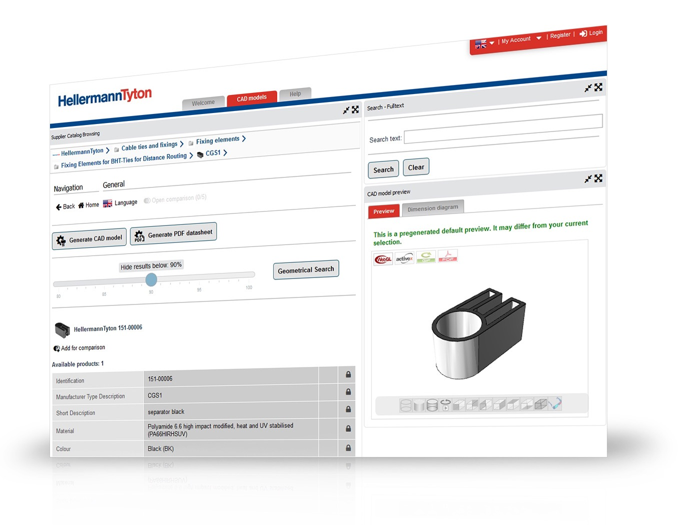
Caption: HellermannTyton‘s 3D CAD models are also available on a dedicated PARTcommunity download portal under http://hellermanntyton.partcommunity.com.

This press release and accompanying images are available for download from our website: www.cadenas.de/press/press-releases

About CADENAS

CADENAS is a leading software developer in the areas of Strategic Parts Management and parts reduction (PARTsolutions), as well as Electronic Product Catalogs (eCATALOGsolutions). With its customized software solutions, the company acts as a link between the component manufacturers with their products and the purchasers.

With its 300 employees at 17 international subsidiaries, the name CADENAS (Hispanic: process chains) has been standing for success, creativity, support and process optimization since 1992.

For further information, please visit:
www.cadenas.de/en

