CADENAS’ 3D CAD download portal PARTcommunity version 4.0 impresses with new features
Benefits for mobile users with comfort due to comfortable user interface

Augsburg, Germany, 25th of June 2015. CADENAS presents the new version 4.0 of its 3D CAD download portal PARTcommunity. Under www.partcommunity.com engineers and purchasers can expect numerous new features, a Look & Feel that has been improved yet again and a download portal optimized for mobile devices.

With the new features of the version 4.0, the search possibilities for 3D CAD models were further expanded. Thus the comparison of 3D CAD models when looking for a suitable part gets even easier. The properties of two or more parts can now be compared by means of a clearly arranged table, containing all important variables. It also informs about the similarity or deviation in percent between the displayed CAD model and the comparison model. This way engineers are supported perfectly when selecting the right part for their design.

Learn from the experience of other engineers and get inspiration for your own designs

Moreover the “Top 10 downloads“ feature, very popular with the users, was further expanded with the new PARTcommunity version. The table shows 3D CAD models that had the most downloads in the last 30 days. Due to the new PARTcommunity version, the top downloads can be filtered for the first time by manufacturer catalogs and countries. By listing the top 10 CAD downloads, engineers can learn from the experience of other users and see at a glance which parts are currently the most popular and are readily used.

Mobile use even more convenient

CADENAS’ 3D CAD download portal PARTcommunity is now also optimized for mobile devices. Users of smartphones and tablets are automatically forwarded to the mobile version. Switching manually from the desktop to the mobile version is no longer necessary.

Also, user handling was made easier. PARTcommunity 4.0, with its mobile version, was especially designed for smaller screens: For this purpose the menu navigation was streamlined and the touch screen control was further improved.

Be in the front line as a component manufacturer due to the PARTcommunity technology

The optimization for mobile devices is a distinct competitive edge, also for component manufacturers:

Since April 2015, Google has been using a new search algorithm, preferring especially those websites optimized for mobile devices. This means these websites are shown up front in the search results. Websites not optimized for smartphones or tablets are ranked down and appear further below in the search results, so that the user might not even see them.

With PARTcommunity version 4.0, the 3D CAD models of the component manufacturers will still be shown at the top of the google search results.

You can find the 3D CAD download portal PARTcommunity under:
www.partcommunity.com

Press Images:

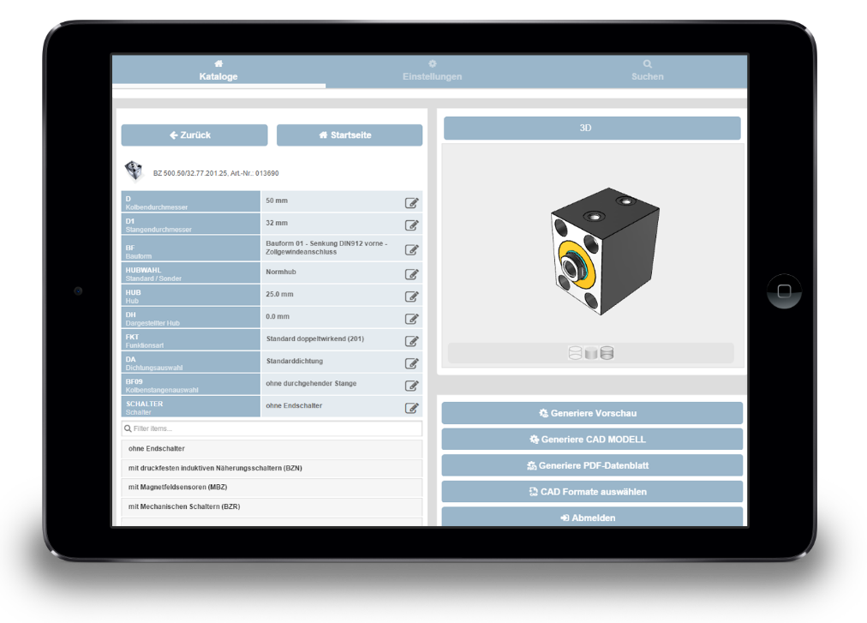
Caption: CADENAS’ 3D CAD download portal PARTcommunity is now also optimized for mobile devices.

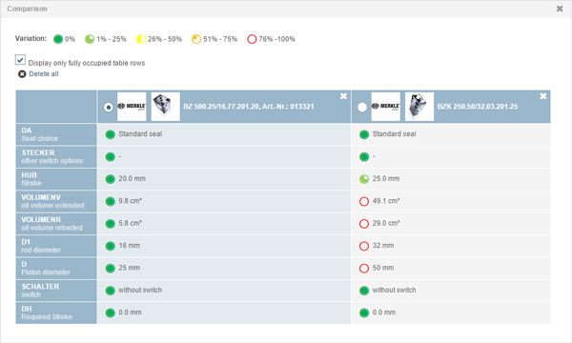
Caption: With the new PARTcommunity version 4.0 comparison of 3D CAD models when looking for a suitable part gets even easier.

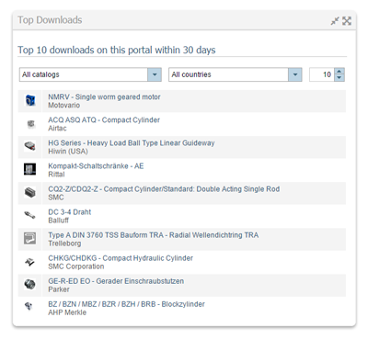
Caption: Due to the new PARTcommunity version, “Top 10 downloads“ feature was further expanded. Users can filter for the first time by manufacturer catalogs and countries.

This press release and accompanying images are available for download from our website: www.cadenas.de/press/press-releases

About CADENAS

CADENAS is a leading software developer in the areas of Strategic Parts Management and parts reduction (PARTsolutions), as well as Electronic Product Catalogs (eCATALOGsolutions). With its customized software solutions, the company acts as a link between the component manufacturers with their products and the purchasers.

With its 300 employees at 17 international subsidiaries, the name CADENAS (Hispanic: process chains) has been standing for success, creativity, support and process optimization since 1992.

For further information, please visit: www.cadenas.de/en

