CADENAS performs a real quantum leap with PARTsolutions version 10
Extended search features and an optimized user interface revolutionize strategic parts management for engineers and purchasers

Augsburg, Germany, 23rd of July 2015. With CADENAS new PARTsolutions version 10, a real quantum leap in the parts management sector was performed, which also revolutionizes the topic “Intelligent Finding“ with many new features and improvements. Engineers and purchasers are provided with significantly improved search features, helping them to find parts in their company and in the parts world without any hassle and in a targeted way. Moreover the intensive development efforts of the software manufacturer from Augsburg brought forth a multitude of impressive highlights. For instance the customized filter assistants, pioneering changes when classifying with the new solution Classification 2.0, display of all component dimensioning in a 3D window and numerous new interfaces to all common CAD-, PLM- und ERP systems.

Simplified use due to clearly arranged design

Due to the new user interface in the flat design, handling of CADENAS parts management is even more intuitive and efficient. This way new users of PARTsolutions can learn the handling simpler and faster. The extensive search feature window is now available in all views allowing a targeted access. Furthermore the search results are organized in clearly arranged multiple tabs. Thus the different search results are visible at any time, which makes the selection of the suitable part significantly easier. Moreover the complete layout in PARTsolutions can be adjusted individually according to the needs of the user.

Get quickly to the required component with the customized filter assistant

The new PARTsolutions version offers engineers a novelty: For the first time, filter assistants can be adjusted to their own requirements by defining the respective filter variables for searching individually and determining the graphical interface. The customized filter assistants generated afterwards can be saved and provided to other users in the team or for the Classification 2.0. Components that are frequently searched for can be found in an uncomplicated and effective way in manufacturing companies. An example for the practical use and success of the customized filter assistants can be read in the mutual case study of the French railway company SNCF. By means of PARTsolutions the company was able to reduce the multiplicity of bolted connection fasteners by 15%.

All component information at a glance

Often engineers do not only need the dimensioning for 2D derivations but also in the 3D view. With the new PARTsolutions version 10, all component information is shown to the user in only one window. Thus it is no longer necessary to tediously switch back and forth between the different display windows. (Table, 2D dimensioning and 3D dimensioning). This way mistakes can be avoided and time spent searching for components can be saved.

Partial 3D similarity search allows finding patterns or arrangements in components

Also the partial 3D similarity search, very popular among engineers, was further developed with the new version of the Strategic Parts Management. Besides small part segments of a component also special geometric arrangements of other parts can be used for the partial 3D similarity search.

Innovative visualization creates clearly arranged search results

In the case of very extensive results of a component search, PARTsolutions now offers the possibility to filter different components by the respective type or category. Due to the clearly arranged visualization of the search results, engineers get a good overview and can narrow the results even simpler to the relevant components.

New interfaces to CAD-, PLM- and ERP systems simplify the work of engineers and purchasers

The PARTsolutions version 10 also scores with many new interfaces to acquainted CAD-, PLM- and ERP systems and seamless integrations. i.e. catalog parts can be taken over with their parts master data into the ERP quickly and easily. This way purchasers can create files of parts master data even easier which also helps to avoid errors occurring by typing the data manually.

Further highlights of the PARTsolutions version 10 are:

- A function wizard allows the search of components without knowing the exact designation. By means of the respective component function, for instance press and lock, the search for the suitable opponent can be started quickly and easily.
- Recognizing topological elements on the basis of the Capvidia functionality was further improved.
- Improved search result lists now also offer a filter possibility. Thus filtering according to fixed values and areas is possible.
- The comparison of components by means of the sectioning function was enhanced.
- Classification 2.0 – a new pioneering method to realize “classification without effort“. Would you like to learn more about CADENAS’ innovation? Please turn to your CADENAS key account manager or consultant.

Enlighten yourself about the many new features of the Strategic Parts Management PARTsolutions under:
www.cadenas.de/strategic-partsmanagement

Press Images:
Caption: With CADENAS new PARTsolutions version 10, a real quantum leap in the parts management sector was performed.
Image source: © fzant / istockphoto.com

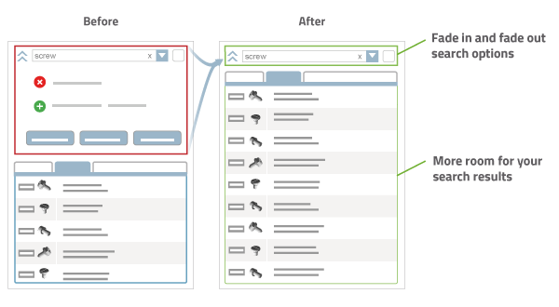
Caption: Due to the new user interface in the flat design it is now possible to handle PARTsolutions a lot more intuitively and efficiently.

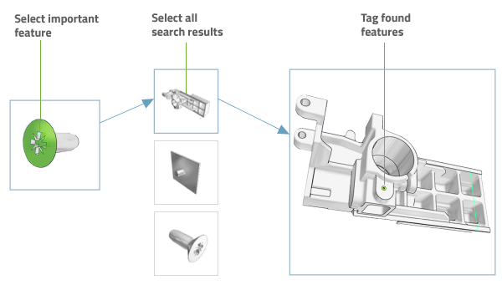
Caption: The partial 3D similarity search makes it possible to find patterns or arrangements in components.

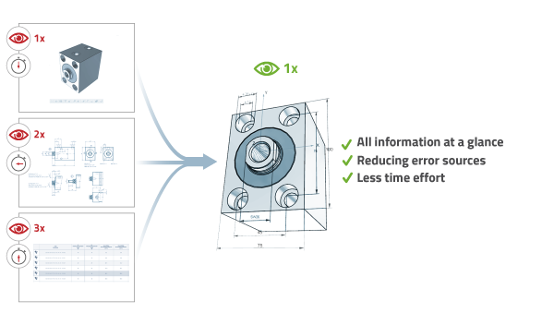
Caption: With the new PARTsolutions version 10 all component information is shown to users in only one window.

This press release and accompanying images are available for download from our website: www.cadenas.de/press/press-releases

About CADENAS

CADENAS is a leading software developer in the areas of Strategic Parts Management and parts reduction (PARTsolutions), as well as Electronic Product Catalogs (eCATALOGsolutions). With its customized software solutions, the company acts as a link between the component manufacturers with their products and the purchasers.

With its 300 employees at 17 international subsidiaries, the name CADENAS (Hispanic: process chains) has been standing for success, creativity, support and process optimization since 1992.

For further information, please visit: www.cadenas.de/en

