PARTsolutions allows OECHSLER further time and cost savings for preparing offers
Supplier from Central Franconia implements CADENAS’ 3D similarity search to optimize the offer management

Augsburg, Germany, 29th October 2015. OECHSLER AG is an independent, innovative and fast-growing company of the plastics processing industry. Among their main customers are renowned companies of the automotive supply industry and medical industry. The company has its head offices in Ansbach and is currently represented at six locations worldwide.

To further improve the offer process, OECHSLER will implement CADENAS’ 3D similarity search of the strategic parts management PARTsolutions in 2016. This tool allows to quickly identify similar products from the extensive database, also in terms of geometrics, during the time sensitive inquiry and offer phase.

Powerful and target-oriented offer process
Many products, such as plastic gearwheels, screws and barrels, are geometrically similar. If a customer, for instance, requests a new gearwheel at OECHSLER, a variety of similar products for offer preparation can be filtered out due to the provided 3D CAD data. For this, the continuous collection of all CAD geometries from requested and current serial parts in production is necessary, as well as drawings of tool concepts, parts calculation and preparing offers. This results, little by little, in an extensive knowledge database. The SAP document management system, which is deeply integrated into all processes at OECHSLER, serves as database for CAD data and offer documents. After collecting the data in SAP, the 3D data is automatically indexed and a digital fingerprint is automatically created in the database of CADENAS. This fingerprint contains all characteristic geometric data of the product in processed, comparable and thus searchable form. With indexing, other meta data is exported from SAP at the same time and transferred to a PARTsolutions catalog. Then this data is available to the offer management for searches.

To know similar products has depended on expert knowledge of experienced employees until now
With the hit list in PARTsolutions, the person responsible can now collect data for a new offer much more efficiently and target-oriented. For this purpose PARTsolutions generates a clearly arranged catalog of similar products with a preview image. This preview is generated from the 3D data and shows the specially prepared data from SAP ERP, like material, substances, existing production tools and documents of similar products.

By means of the search results, the responsible person can now also access many other data from the SAP document management system, which show for instance production, processing and packing data and allow conclusions to be drawn for familiar processing problems. In the past, unexpected problems occurred with certain geometries and plastics, like burr formation, streaks, warping or difficulties with demoulding. With the new approach, scrap can already be specified in the offer. The access to process parameters of production and the classification of tools and injection moulding machines make the information options complete.

Even offers that do not lead to a customer order contain a lot of know-how and sophisticated performance
Offers created in this new way are afterwards fed into the SAP document management system together with the CAD data of the customer request. Thus we come about a full circle and also this new offer is then available for new requests as a source of knowledge. Naturally not every new offer immediately leads to a customer order. The requests collected this way are preserved in the knowledge database and the rendered performance is not lost.

“The complex analysis and reasearch effort can be reduced by 50 % this way. Offers are prepared more quickly and risky products are recognized and rated already during the offer preparation, due to a significantly more solid database“, says Markus Deuter, project manager at OECHSLER AG.

Press Images:

Caption 1: Supplier from Central Franconia implements CADENAS’ 3D similarity search to optimize the offer management.

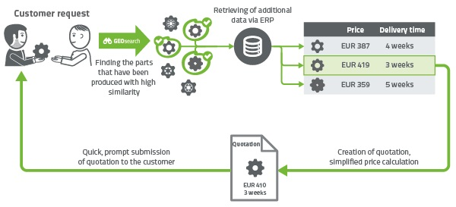
Caption 2: If a customer, for instance, requests a new gearwheel at OECHSLER, a variety of similar products for offer preparation can be filtered out due to the provided 3D CAD data.

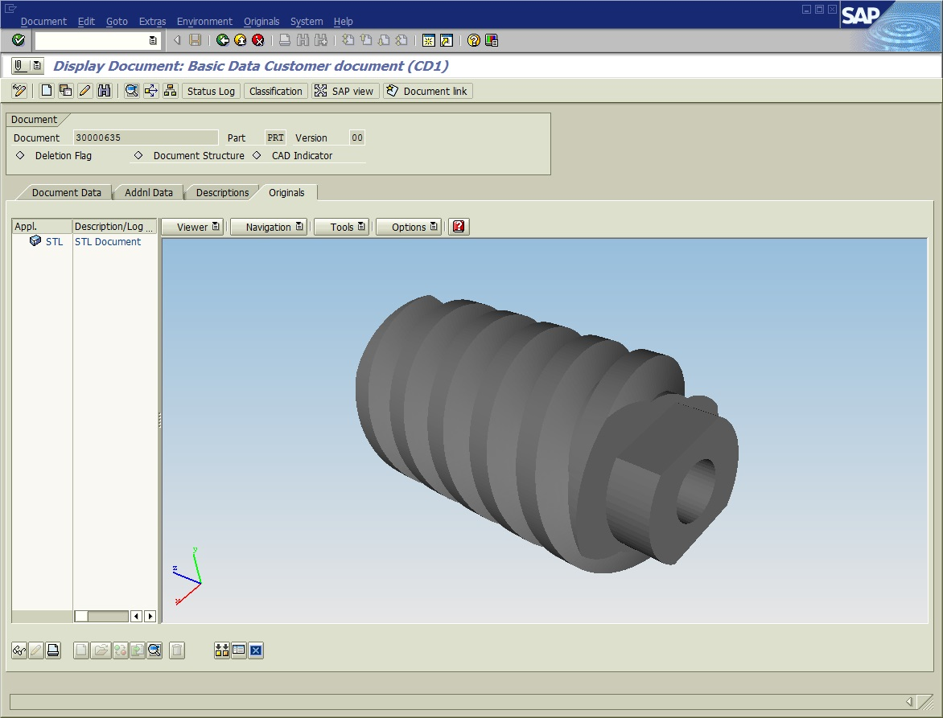

Caption 3: Example for a CAD model in the database of supplier OECHSLER.

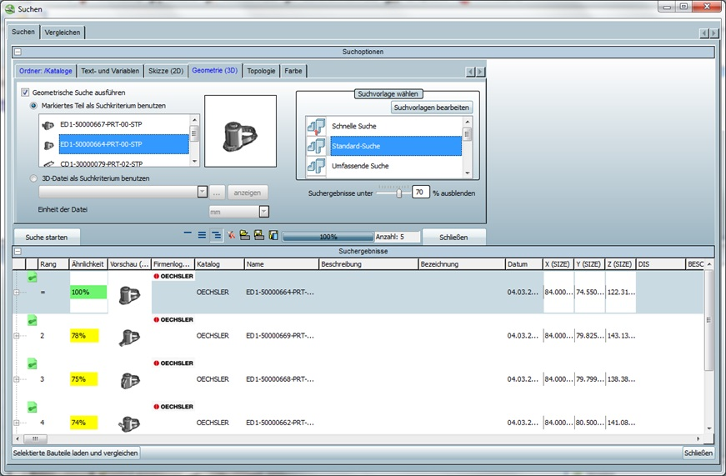

Caption 4: PARTsolutions powered by CADENAS at OECHSLER AG.

This press release and accompanying images are available for download from our website: www.cadenas.de/press/press-releases

About CADENAS

CADENAS is a leading software developer in the areas of Strategic Parts Management and parts reduction (PARTsolutions), as well as Electronic Product Catalogs (eCATALOGsolutions). With its customized software solutions, the company acts as a link between the component manufacturers with their products and the purchasers.

With its 300 employees at 17 international subsidiaries, the name CADENAS (Hispanic: process chains) has been standing for success, creativity, support and process optimization since 1992.

For further information, please visit: www.cadenas.de/en

