"Excellent Presentation of SKF Lubrication Products!"
Introduction of the CADENAS electronic product catalog

Augsburg, Berlin, 10th January 2011. SKF Lubrication Systems Germany AG publishes their new electronic CAD product catalog based on the eCATALOGsolutions technology provided by CADENAS GmbH. The centralized lubrication technology for machines and systems supplier's product catalog is now available on the website http://skf-lubrication.partcommunity.com. Customers and other interested parties can directly access, download and simply integrate the SKF Lubrication Systems 3D CAD models in their constructions. As a first step, the standardized MonoFlex single-line distributor product series are available. Further products and product series will follow.

3D CAD data in native format
The SKF Lubrication CAD catalog was developed in close partnership with the Augsburg-based software manufacturer CADENAS. "Our customers now have the option of configuring our standard products and integrating them in their construction process as 3D CAD data in native format with the corresponding material number," said Jürgen Kreutzkämper, Director of Research and Development at SKF Lubrication Systems Germany AG. In that format, the CAD models can then be imported into the respective CAD system with no further editing necessary.

To coincide with the introduction of the CAD catalog, the SKF Lubrication Systems product program is being streamlined and modernized as well as being adapted to precisely defined standard variation modular systems.

SKF Lubrication 3D models available worldwide
Thanks to the 3D CAD product catalog developed in partnership with CADENAS, SKF Lubrication Systems Germany AG standard products are now available worldwide at all times. "The electronic product catalog and the 3D CAD models are an excellent presentation of our products. Both our customers as well as our sales department benefit from this form of providing information," said Ingo Wagner, Head of Sales at SKF Lubrication Systems. The eCATALOGsolutions electronic product catalog also improves the internal processes at SKF Lubrication by considerably reducing the effort required in providing 3D CAD models.

Furthermore, the eCATALOGsolutions software solution statistics and evaluation tools provide SKF Lubrication with the possibility of optimally analyzing the product catalog download protocol for marketing purposes.

"We are proud that with SKF Lubrication we were able to convince another member of the SKF Group with our software solution. We are pleased to be able to welcome SKF Lubrication as a new customer," said Jürgen Heimbach, CEO of CADENAS GmbH.

Press Images

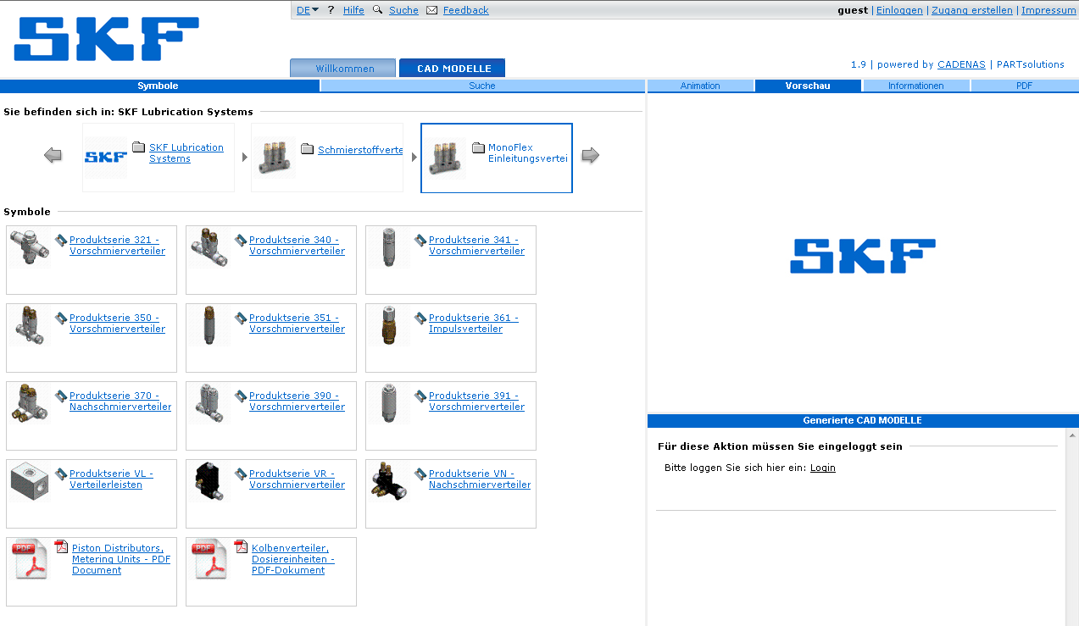
Caption 1: The SKF Lubrication Systems Germany AG electronic 3D CAD product catalog, based on CADENAS eCATALOGsolutions technology.

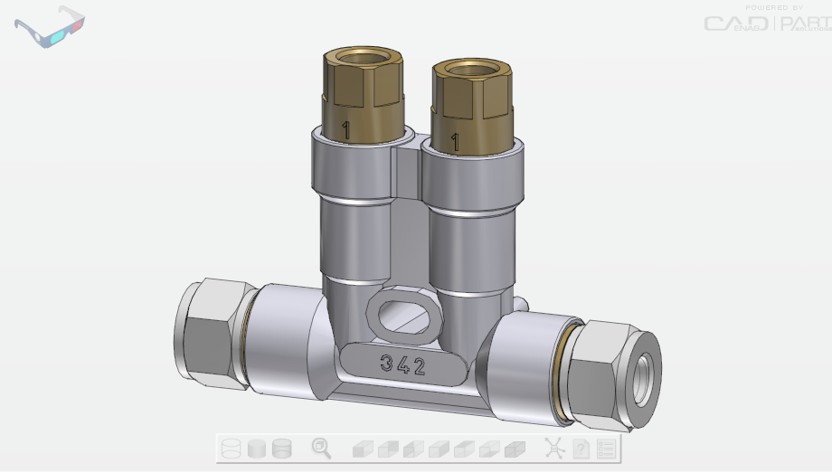
Caption 2: 3D CAD models of the MonoFlex single-line distributors from SKF Lubrication are now available to download. More will follow.

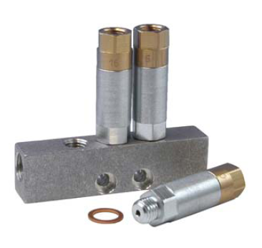
Caption 3: All standard product data for the lubrication single-line distributors from SKF Lubrication are now available worldwide at all times.

2,828 characters

Images and text are available for download on the following websites:

- At www.cadenas.co.uk under:
News & Events / Press releases

- At www.skf.com/lubrication under:
"Latest news"

About CADENAS GmbH

The CADENAS company is a leading software manufacturer in the fields of strategic parts management, parts reduction (PARTsolutions) and electronic CAD product catalogs (eCATALOGsolutions). With their tailor-made software solutions, the company provides a link between component manufacturers and their products and consumers.

The name CADENAS (Spanish for process chains) has stood for success, creativity, consulting and process optimization for over 12 years with 300 employees in 12 international locations.

In the role of initiator and forward-thinker, CADENAS has already established many important innovations and trends in both business fields.

PARTsolutions innovations:
- Search CAD components using topologies
- Similarity search of CAD components starts automatically in the background
- CAD part search by sketches

eCATALOGsolutions innovations:
- Search for 3D CAD parts on mobile telephones
- Use of the Quick Response code
- Use of 3D glasses for the presentation of CAD models
- Control of 3D parts using Wii remote control
- Support of augmented reality technology

Further information about the latest innovations and the company can be found on our website at: www.cadenas.co.uk.

About SKF Lubrication Systems Germany AG

SKF has over 100 years experience with moving machine parts. That is why SKF has unique knowledge about the subject of lubrication. That not only includes know-how about the construction and engineering of tailor made lubrication systems. Today, we offer the complete range of lubrication solutions: from specialist lubrication materials and manual lubrication devices to the most advanced automatic centralized lubrication systems available on the market.

SKF Lubrication Systems Germany AG, with approx. 600 employees at the Berlin and Hockenheim locations and numerous international branches and partners, is the competence center for the SKF Lubrication Solutions division. We are the leading worldwide supplier of centralized lubrication technology for machines and systems in industry, for commercial and railway vehicles and minimal quantity lubrication for the improvement of metal processing.

Contact

SKF Lubrication Systems Germany AG
Motzener Straße 35/37
12277 Berlin
Tel.: + 49 (0) 30 72002-109
Fax: +49 (0) 30 72002-349
www.skf.com/lubrication

