CADENAS Industry-Forum 2012 will present numerous high-class presentations
Specialist conference in February 2012 informs mechanical and plant engineering experts

Augsburg, 12th January 2012. On 8th and 9th February 2012 the software developer from Augsburg, the CADENAS GmbH, will organize the Industry-Forum at the IHK Augsburg for the 13th time. The international specialist conference targets component manufacturers and experts of the mechanical, plant and engineering industries as well as electrical engineering industries.

Top-class speakers from renowned companies

In 2012 the Industry-Forum presents itself with top-class speakers from renowned companies who will give an exclusive insight, with their best-practice presentations, into their experience and strategies when using the software solutions of CADENAS. The program will include presentations of the following companies: The Boeing Company, Liebherr-Werk Biberach GmbH, Siemens VAI Metals Technologies GmbH, AHP Merkle GmbH, eCl@ss e.V., Thales Alenia Space Italia S.p.A., Balluff GmbH, FATH GmbH and REpower Systems SE.

Reduce process costs in the construction phase

Presentation topics, workshops and networking in the fields of Strategic Parts Management especially target companies, who want to, in the long term, reduce costs during the construction phase which cannot be influenced at a later time. Moreover the presentation of CADENAS‘ PURCHINEERING concept shows visitors, how to achieve an optimized cooperation of purchasing and engineering.

Electronic Product Catalogs revolutionize marketing

The Industry-Forum 2012 offers inspiring practical examples to component manufacturers, on how to revolutionize marketing with the Electronic Product Catalog by CADENAS. Additionally the visitors will experience how they can increase interest in their electronic CAD product catalogs and at the same time boost sales with cutting edge marketing strategies, like the vertical market places and innovative tradeshow-features.

During the 13th CADENAS Industry-Forum there will also be a trade exhibition of renowned companies.

The evening event of the Industry-Forum offers a further possibility for networking. It will take place subsequent to the first conference day. Here, the participants can make new and valuable contacts in a relaxing atmosphere.

For further information about presentations and registration, please visit:
www.industry-forum.biz/forum
Press pictures

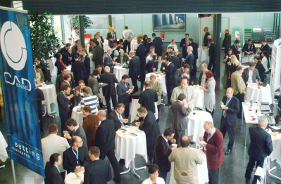

Caption 1: Every year CADENAS‘ international specialist conference, the Industry Forum, attracts around 250 experts from mechanical- and plant engineering industries.

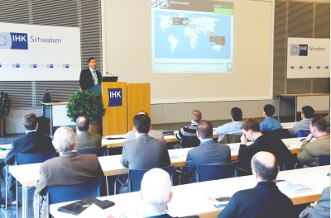

Caption 2: Jürgen Heimbach, CEO of the CADENAS GmbH, presented the latest strategies of the software developer from Augsburg at the 12th Industry Forum in 2011.

2,573 characters

The press text and pictures are available for download on our website under: www.cadenas.co.uk/press-releases

About the CADENAS GmbH

CADENAS is a leading software developer in the areas of Strategic Parts Management and parts reduction (PARTsolutions), as well as electronic product catalogs (eCATALOGsolutions). With its customized software solutions, the company acts as a link between the component manufacturers with their products and the purchasers.

With its 300 employees at 14 international subsidiaries, the name CADENAS (Hispanic: process chains) has been standing for success, creativity, support and process optimization for 19 years.

In its role as initiator and mastermind, CADENAS has already established many innovations and trends.

PARTsolutions Innovatios:
- Topology search for CAD components
- Geometric similarity search of CAD components runs automatically in the background
- Search for CAD parts by sketching

eCATALOGsolutions Innovations:
- Search for 3D CAD parts on smartphones
- Use 3D glasses to present CAD models
- Navigate 3D CAD parts with a Wii remote control
- Support of the Augmented Reality Technology
- ePRODUCTplacement: Offer the right part to the right person at the right time.

For further information about our newest innovations and the company, please visit our website under: www.cadenas.co.uk.

