Festo Makes Patent for Product Configuration Available to CADENAS Customers
CADENAS’ customers obtain right to use product configuration with CAD automation

Augsburg, July 13, 2011. Festo AG & Co. KG makes their patent for the process of the product configuration with CAD automation available to customers of CADENAS GmbH. The Festo process of product configuration with CAD automation has already been under protection of the European Patent EP 1 251 444 B1 since October 12, 2005. Patent owner is Festo AG & Co. KG (Esslingen). CADENAS GmbH and their customers are allowed to use this patent.

Festo AG is a worldwide leader in automation engineering and has been offering its customers an online product configurator since 2009. This enables a combination of Festo components and the subsequent export of 3D CAD geometries. Festo’s products can be thus customized to the requirements of customers and then made available.

The self-explaining interactive product configurator from CADENAS’ software solutions eCATALOGsolutions, gives customers the opportunity to plan as they wish, create offers based on the Bill of Materials (BOM) list and then carry out this order. This contributes to optimize processes in the company and considerably minimize processing times. In addition, a comfortable user interface ensures saving time already during the planning stage.

Press Image
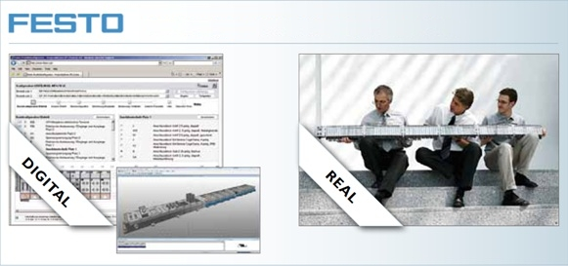
Caption: Since 2009, Festo AG & Co. KG offers an online product configurator.

1 368 characters

The press text and the image can be downloaded on our website at www.cadenas.co.uk
News & Events / Press Releases

About CADENAS GmbH

CADENAS is a leading software manufacturer in the areas of strategic parts management, parts reduction (PARTsolutions) as well as electronic product catalogs (eCATALOGsolutions). With its customized software solutions, the company acts as a link between the component manufacturers and their products, and their buyers.

With over 300 employees at 14 different locations worldwide, the name CADENAS (Spanish for process chains) has stood for creativity, success, support and process optimization for over 19 years.

In its role as initiator and mastermind, CADENAS has already established many innovations and trends in the two areas of business.

PARTsolutions innovations:
- The search for CAD parts using topologies
- The geometric similarity search for CAD parts runs in the background automatically
- The CAD part search via sketches

eCATALOGsolutions innovations:
- The search for 3D CAD parts on smartphones
- The use of 3D glasses to present CAD models
- Controlling 3D CAD parts with the help of the Wii remote control
- Support by the Augmented Reality technology
- ePRODUCTplacement: Offering the right part to the right person at the right time

More information about the newest innovations as well as the company in general can be found on our website under: www.cadenas.co.uk.

