New features and a fresh design - CADENAS app even more indispensable than before
The PARTcommunity 3D CAD models app excels in new design with extended search and comfort functions
AUGSBURG, Germany, November 13th 2014 – The PARTcommunity 3D CAD models app, especially popular among engineers, was upgraded once again: the app, offering access to millions of 3D CAD models from over 400 manufacturer certified catalogs of renowned companies, excels in a new, fresh design with new features.

Even more indispensable than before with a better overview and extended search functions

The app, which has been downloaded over 450.000 times since its introduction in 2012, has become an indispensable tool for users in the field of engineering and procurement. In the latest version, CADENAS significantly elaborated and optimized the functions: Besides the design, the sketch search was also improved. With the new version, the desired part can be automatically searched across all available catalogs. Moreover, a part that has already been opened can be used as a search template for the Geometric Similarity Search GEOsearch. This component is then compared in a search run to other parts from other catalogs and catalog areas.

Also the sharing functions were extended and now allow you to share the found objects by default via the social network sites LinkedIn, Pinterest and Google+.

Success through constant improvement and extension

The PARTcommunity 3D CAD models app has been constantly improved and updated since its introduction. “We are very happy about the sensational success of the PARTcommunity 3D CAD models app. It shows us that the CADENAS app is exactly what engineers and purchasers need for their daily work and therefore use it frequently“, says Jürgen Heimbach, CEO of CADENAS. “CADENAS will not rest on these laurels, instead the great popularity of the app motivates us to constantly improve the features and continue to extend the scope of functions.“

You find more information about the PARTcommunity 3D CAD models app by CADENAS in the following video: http://youtu.be/nhNaTVvvtEY

The PARTcommunity 3D CAD models app can be downloaded for iOS and Android at: www.cadenas.de/en/app-store

Press Images:

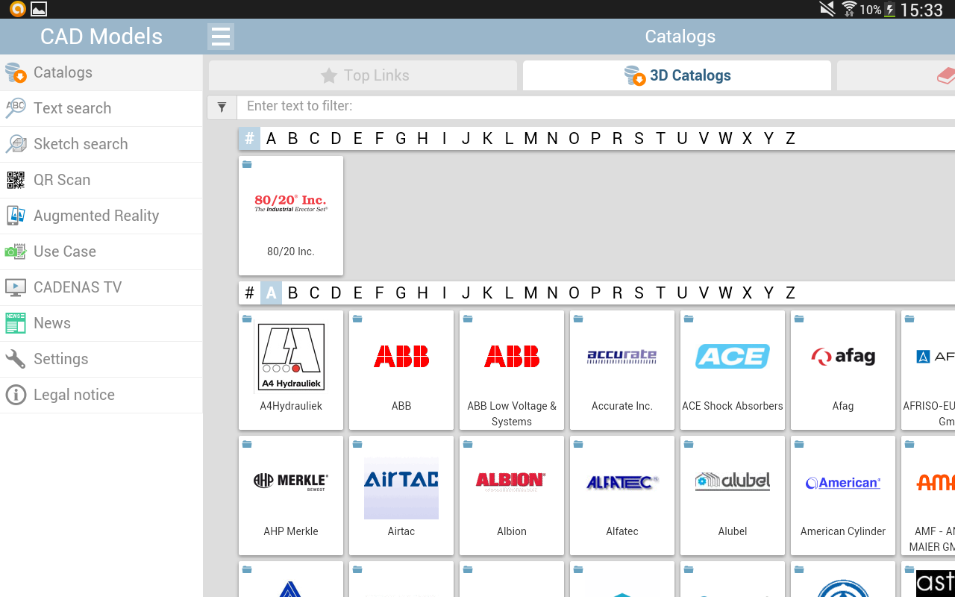
Caption 1: With the new version of the PARTcommunity 3D CAD models app the desired part can be automatically searched across all available catalogs.

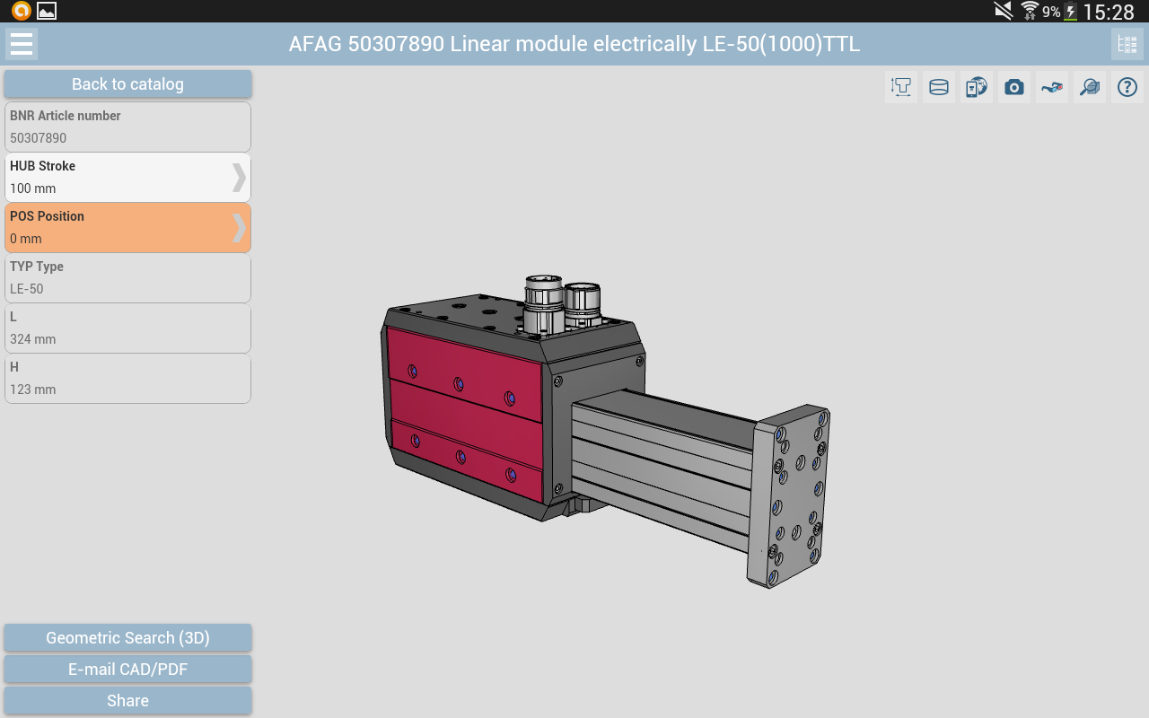

Caption 2: A part that has already been opened can now be used as a search template for the Geometric Similarity Search GEOsearch

About CADENAS

CADENAS is a leading software developer in the areas of Strategic Parts Management and parts reduction (PARTsolutions), as well as Electronic Product Catalogs (eCATALOGsolutions). With its customized software solutions, the company acts as a link between the component manufacturers with their products and the purchasers.

With its 300 employees at 14 international subsidiaries, the name CADENAS (Hispanic: process chains) has been standing for success, creativity, support and process optimization since 1992.

For further information, please visit: www.cadenas.de/en

