RS Components Available with Master Data Product Catalog in CADENAS PARTsolutions
Availability of all digital product data from RS Components

Augsburg, Mörfelden-Walldorf, 9th of August 2011. RS Components GmbH, a leading distributor in the areas of electronic and automation, is making its product data available in digital form for the strategic parts management PARTsolutions. PARTsolutions is a software solution designed by CADENAS GmbH, an Augsburg software manufacturer, and it contains a certified interface to SAP material management.

For SAP users, the manual creation of material master data is often very time consuming and defective. With the help of PARTsolutions, RS‘s product data is now made available digitally and can be used by PARTsolutions users directly without data loss. This saves RS SAP customers an enormous amount of time while simultaneously lowering costs.

The strategic parts management system PARTsolutions by CADENAS thus enables the master product data from RS to be seamlessly integrated into the SAP material logistics. The integration contains the certification "Powered by NetWeaver" and supports the creation, change and display of material master records.

The digital RS product data contains, among other things, master data such as order number, short and long description, packaging amount, planned time of delivery, European Article Number (EAN), and eCl@ss number. In addition to the general master data information, CADENAS PARTsolutions links directly to the online datasheet.

Creating master data optimally

Through the SAP integration material master data fields are filled automatically with PARTsolutions attributes. If a user selects an RS product dataset in PARTsolutions, the SAP material master data are automatically transferred into the SAP layout template.

Benefits for SAP users

- Significant reduction of effort and time saving concerning the creation of master data
- Automatic data transfer
- No input mistakes, optimization of data quality
- No data redundancy through visualization of duplicates
- Up-to-date master data through continuous catalog updates
- Due to the separated data management in the PARTsolutions catalog, the solution is independent of the functional database
Press Images

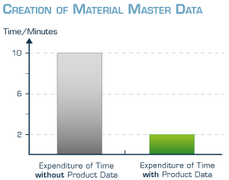

Image caption 1: Digital product data from RS Components in PARTsolutions simplifies the creation of SAP material master data.

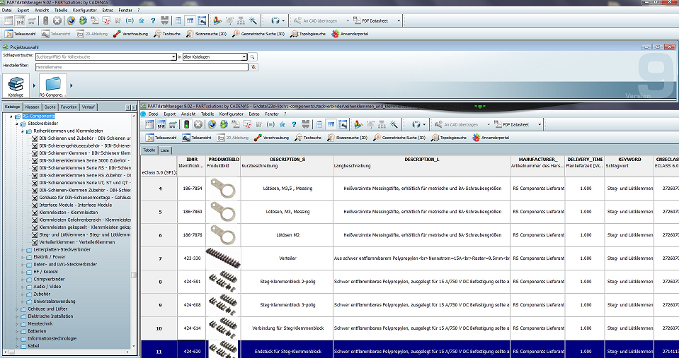

Image caption 2: RS Components product data in the strategic parts management CADENAS PARTsolutions.

2,274 characters

The press release and photos are available for downloading on our website: www.cadenas.co.uk
News & Events / Press releases

About CADENAS GmbH

CADENAS a leading software manufacturer in the areas of strategic parts management and parts reduction (PARTsolutions) as well as electronic CAD product catalogs (eCATALOGsolutions). With its customized software solutions, the company acts as a link between component manufacturers and their products, and the buyers.

With it 300 employees at 14 international locations, the name CADENAS (Spanish for ‘chains’) has stood for success, creativity, consultation and process optimization for over 19 years.

In its role as initiator and mastermind, CADENAS has already succeeded in establishing many innovations and trends.

PARTsolutions Innovations:

- The search for CAD parts using topologies
- The geometric similarity search using CAD parts runs in the background automatically
- The CAD parts search by sketches

More information about the newest innovations as well as the company in general can be found on our website under: www.cadenas.co.uk.

About RS Components GmbH

RS is one of the leading distributors for small and medium volume requirements in the electronic and automation industries. The company quickly and securely delivers over 500,000 products for research and development, pre-series and small series production, as well as in maintenance. The up to date German distribution center in Bad Hersfeld guarantees delivery on the same or next business day within its core range. Due to the development of its e-commerce competency, RS is able to offer small and medium-sized enterprises, such as enterprises, intersectional and global innovative products and help them in optimizing the electronic buying process as well as reducing the process costs. Among others, German clients include Carl Zeiss AG, Continental AG, Daimler AG, Deutsche Bahn AG, Deutsches Zentrum für Luft- und Raumfahrt e.V., EON AG, EnBW AG, Karlsruher Institut für Technologie, Fraunhofer Institute, Helmholtz-Gemeinschaft, Infineon Technologies AG, Knorr-Bremse AG, Max Planck-Institute, RWE AG, Siemens AG, Thyssen Krupp AG, Vattenfall Deutschland GmbH, Volkswagen AG.

More information under www.rsonline.de/presse

Contact

RS Components GmbH
Hessenring 13 b
64546 Mörfelden-Walldorf
Phone: +49 (0)6105/401-0
E-Mail: rs-gmbh@rsonline.de
http://www.rsonline.de

