Brilliant Product Images without a Photographer
New eCATALOGsolutions interface enables rendered images at the push of a button

Augsburg, 8th November 2010. Goodbye photographer sessions: With the newly developed interface for a 3D rendering program, products from the electronic product catalog eCATALOGsolutions by CADENAS GmbH will shine. Now, component manufacturers can create photorealistic images from their existing 3D geometries at the touch of a button in eCATALOGsolutions.

The razor sharp rendered images are possible thanks to a new interface of the Maxwell Render software by Next Limit Technologies. The difference to a professional photographer’s product photo is almost unrecognizable to the naked eye. “We´re very pleased to see CADENAS providing an interface between Maxwell Render and eCATALOGsolutions for their clients, bringing the quality of Maxwell Render to a new audience”, said Victor Gonzalez the CEO of Next Limit Technologies.

Save Costs Effectively

Until now, products were often photographed by professional photographers. This caused logistic, organizational and personal costs. By using rendered images, these costs can be significantly reduced in the future.

The high resolution images of the 3D rendering can be used, for example, on websites, in paper catalogs, CD-ROMs, or, on posters at the tradeshow booth of a manufacturer.

Press Photos

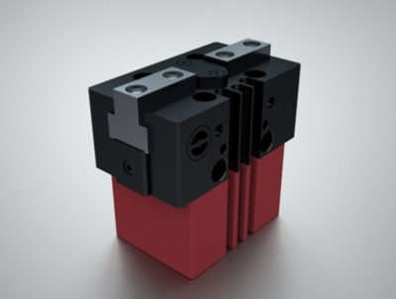
Caption 1: Afag Automation AG - Universal Gripper.

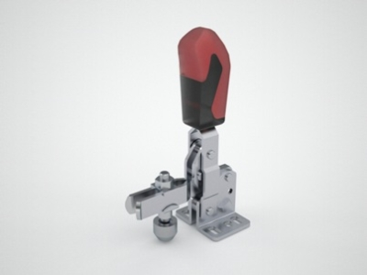

Caption 2: AMF Andreas Maier GmbH - Toggle Clamp.

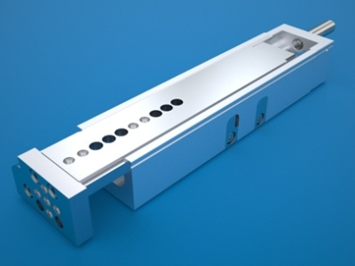

Caption 3: Festo AG - DGSL.

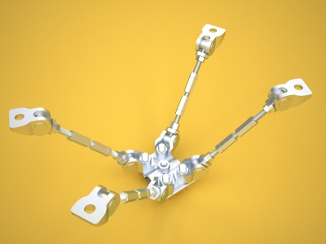

Caption 4: SIKLA Austria GmbH - Positioning Spider.

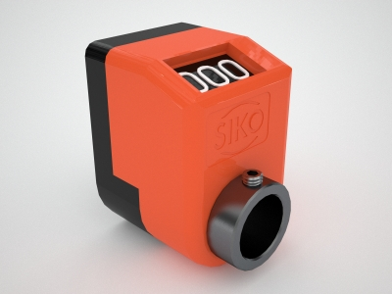

Caption 5: SIKO GmbH - Position Indicator.

The press release and the photos are available for download under: www.cadenas.co.uk
News & Events / Press Release

About CADENAS GmbH

CADENAS is a leading software manufacturer in the areas strategic parts management and parts reduction (PARTsolutions) as well as electronic product catalogs (eCATALOGsolutions). With its customized software solutions, the company acts as a link between the component manufacturers and their products and the purchasers.

With its 300 employees in 12 locations worldwide, the name CADENAS (Spanish for “process chains”) has stood for success, creativity, support, and process optimization for over 18 years.

In the role of initiator and mastermind, CADENAS has already established many innovations and trends. These include:

- Part selection through sketching
- The 3-D similarity search
- The mobile search
- Use of the Quick Response Codes
- Use of 3-D glasses
- Controlling 3-D parts with the help of Wii remote control
- Support of the Augmented Reality Technology

More information about the newest innovations as well as the company in general can be found on our homepage under: www.cadenas.co.uk.

About Next Limit Technologies

The mission of Next Limit Technologies is to provide cutting edge simulation technologies for a broad range of applications in Computer Graphics, Science and Engineering. Next Limit boasts a young, multidisciplinary team with expertise in physics, mathematics, computer graphics, engineering and visualization. They all share a common vision for the creation of new products that connect science, simulation and visualization using novel paradigms and innovative methodologies.

Next Limit's products include "RealFlow" (fluid and dynamics simulation for 3D visual effects), "Maxwell Render" (physically accurate light simulation and render engine) and "XFlow" (CFD software for engineering and scientific applications).

A demo version of Maxwell Render v2 can be downloaded from www.maxwellrender.com. The plug-ins come as seperate downloads.

More information under: http://www.nextlimit.com.

