Future-oriented technology at the CADENAS Industry-Forum 2017

International convention with focus on Industry 4.0, BIM and optimizing the design process

Germany, Augsburg, 29th March 2017. The 18th Industry-Forum of CADENAS GmbH welcomed over 200 national and international visitors from the areas of machine and plant engineering, electrical engineering as well as architecture, who were informed about trends and developments in Strategic Parts Management, Electronic Product Catalogs and Building Information Modeling (BIM). At this year's international convention, which took place in the WWK Arena in Augsburg, Germany, from 15 - 16 March 2017, the main topics were Industry 4.0, BIM and the optimization of the design process.

Plenty of innovations and anecdotes from 25 years of CADENAS
During his opening speech at this year's anniversary, Jürgen Heimbach, CEO of CADENAS GmbH, presented some exciting highlights as well as amusing anecdotes and flashbacks from the past 25 years of the German software manufacturer. This shows that CADENAS has set important trends early on and paved the way for the future at all times. "CADENAS has grown from a small company to become a software manufacturer with 320 employees in 12 countries within the past 25 years. During this time, we have promoted over 500 innovations. Currently there are more than 5000 future-oriented ideas in our knowledge database we wish to implement," said Jürgen Heimbach. "In doing so, our focus will mainly be on the following three areas: deeper integration of Strategic Parts Management in CAD, PLM and ERP systems, expansion of methods for the intelligent finding of components as well as the promotion of eBusiness."

Frank Epple, CTO of CADENAS, also talked about innovations and trends. Together with Jürgen Heimbach, he gave the professional visitors exclusive insights into new functions and improved features of PARTsolutions Version 11. In particular for the intelligent finding of components, the Strategic Parts Management holds advanced options and improved search options in store. In the Topology Search, component samples are now automatically recognized and involved in the search. In the Geometric Similarity Search, mirrored components are specifically indicated and for the first time, individual elements can be marked in an object within the Partial Search function. Only the selected elements are then involved in searching for similar components.

Practical experience reports and application-oriented workshops
Following the opening speech, user presentations from well-known companies offered numerous suggestions and information about the practical use of CADENAS software solutions. In the area of Strategic Parts Management, the visiting professionals learned, among other things, how search times for components are drastically reduced, thanks to PARTsolutions, and the cost savings that are possible. Moreover, well-known industrial companies demonstrated how they have integrated the software solution PARTsolutions into the existing system landscape. In the area of Electronic Product Catalogs, component manufacturers explained how they market their products successfully with the eCATALOGsolutions software solution and, for example, present them with photorealistic product images. Besides detailed information on BIM and the advantages of 3D CAD BIM models for digital building, the participants were also given exclusive insights into the numerous innovations of Version 7.0 of the 3D CAD models download portal PARTcommunity from CADENAS.

The 19 Best Practice presentations were accompanied by practical workshops about "PURCHINEERING – How purchasing comes into play early on" as well as "Digital Twin – How the Electronic Product Catalog is ready for Industry 4.0". The visitors were explained how data from the Electronic Product Catalog is useful for the Mechatronics Concept Designer.

For the first time within the Industry-Forum, chosen manufacturers were awarded the CADENAS "The Golden Catalog Seal". The golden catalog seal distinguishes the Electronic Product Catalogs which provide an integration of a product configurator, an automatic 2D dimensioning for CAD components and product data in at least three languages.

The many visitors were excited about the two-day CADENAS convention. "The Industry-Forum was once again a success, where many interesting topics were reported on. The topic "Data transfer from SAP classification into CADENAS" was especially interesting. We are eager to see how the development will continue," said Dirk Noske of SIG Combibloc Systems GmbH. Anatol Kligermann of Balluff GmbH also appreciates the forum as an information platform. "Participation in the Industry-Forum presents the perfect opportunity to compare the vector of your own development to that of the vector as a whole and to adjust your own niveau according to the generally achieved niveau, to inspire the exchange with the latest information and to bring work impulses that will last till the next forum."

Exclusive insights into the future project Hyperloop from SpaceX
As one of the pioneers of detecting new trends and technologies, CADENAS invited two teams of students of the Hyperloop Project to the Industry-Forum 2017. The so-called Hyperloop Alpha Study for high-speed transport systems was publicly advertised by Elon Musk, also known for his participation in Tesla Motors and the founding of SpaceX. The Hyperloop team of Ryerson University in Toronto introduced its innovative braking system and showed how designs are accelerated with AIA NAS standard parts from CADENAS.

In the accompanying exhibition of the Industry Forum, the WARR Hyperloop team of the TU Munich gave interested visitors insights into the concept of their award-winning hyperloop capsule. "The Hyperloop Project is so exciting because it's about building something that's never been tried before. Some of the technologies we use already exist in other application areas. But we combine them entirely new and under other framework conditions, such as in a vacuum," reports Gabriele Semino from the WARR Hyperloop team of the TU Munich.

Be Irish for a day and networking at the evening event
In preparation for the traditional Irish St. Patricks Day on March 17, CADENAS showed how to celebrate on the green island as part of the traditional evening event. This included: Irish live music, Irish food and Irish national drinks. The participants had the opportunity to exchange ideas with other participants in a relaxed atmosphere.

Further information about the CADENAS Industry-Forum can be found at:
www.industry-forum.biz

Impression of the evening event as well as pictures and presentations can be downloaded at: www.industry-forum.biz/review/2017

Press Images
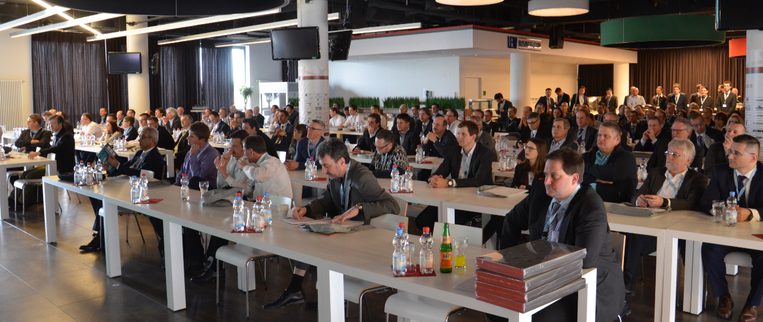

Caption 1: The 18th Industry-Forum of CADENAS GmbH welcomed over 200 national and international visitors from the areas of machine and plant engineering, electrical engineering as well as architecture, who were informed about trends and developments in Strategic Parts Management, Electronic Product Catalogs and Building Information Modeling (BIM).

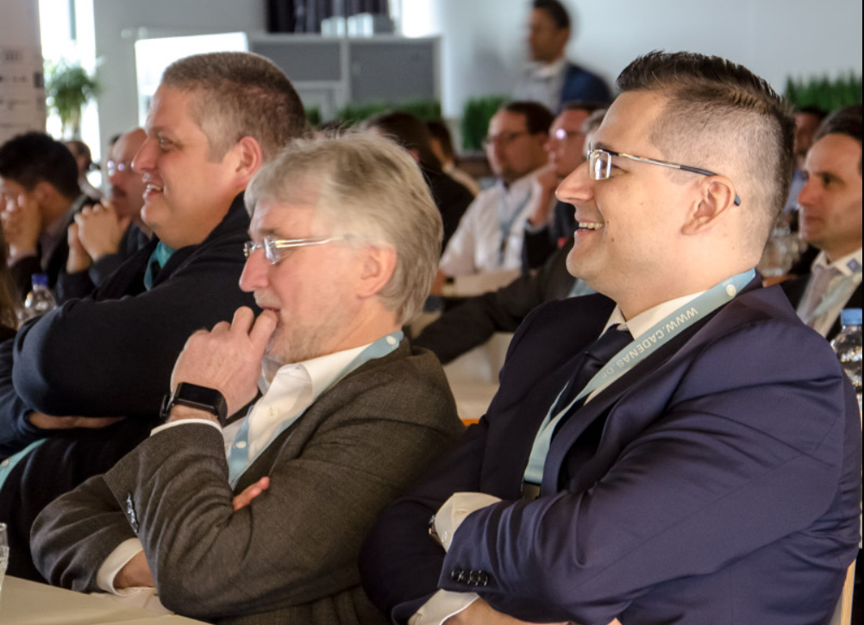
Caption 2: 19 Best Practice presentation gave the participants numerous suggestions and information on the practical use of CADENAS software solutions.

Caption 3: During his opening speech at this year's anniversary, Jürgen Heimbach, CEO of CADENAS GmbH, presented some exciting highlights as well as amusing anecdotes and flashbacks from the past 25 years of the German software manufacturer.
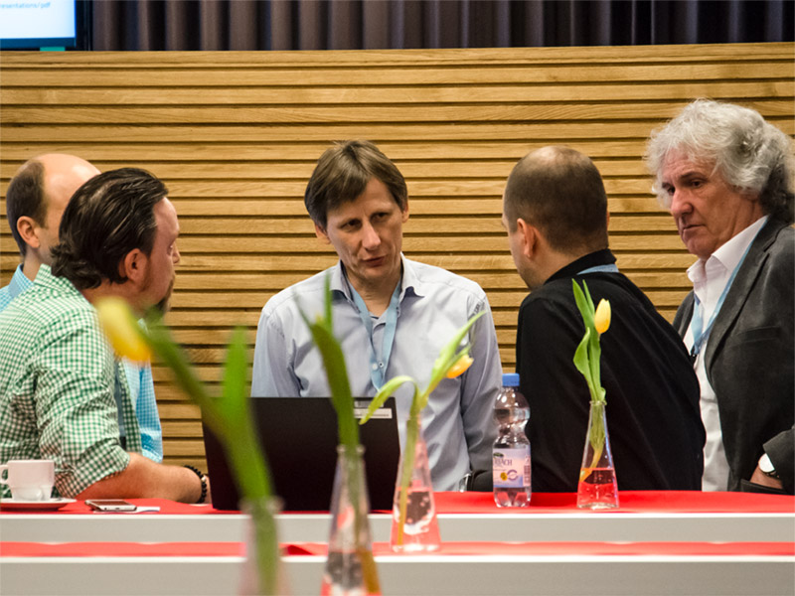
Caption 4: Between the numerous Best Practice presentations, the professional visitors of the Industry-Forum had the chance to exchange ideas with other users of CADENAS software solutions.

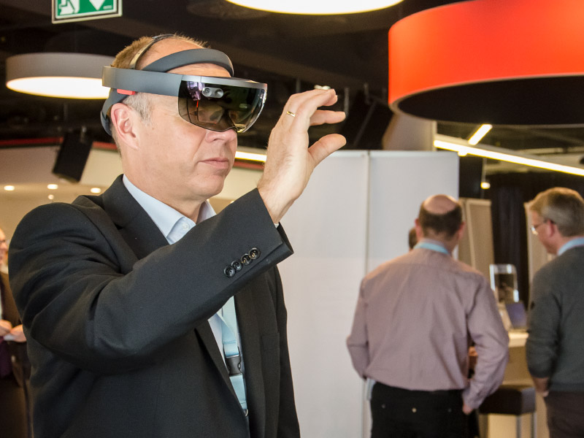
Caption 5: An informative exhibition accompanied the CADENAS Industry-Forum and also offered the opportunity for the hands-on testing of the latest trends and technologies, such as the Microsoft HoloLens.

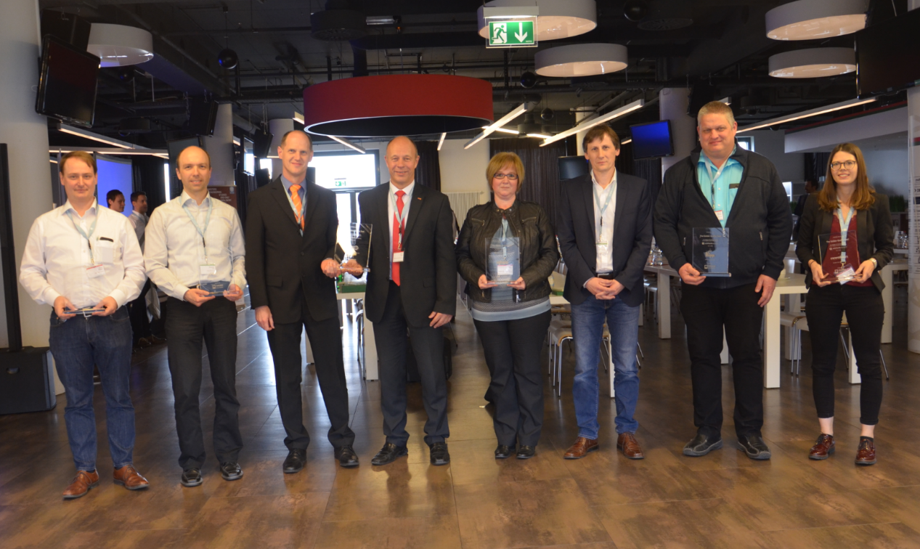
Caption 6: Some of the happy winners of the CADENAS Award „The Golden Catalog Seal”.

Caption 7: At the evening event, under the motto „Be Irish for a day“, the participants talked with one another in a relaxed atmosphere.

The press release and pictures are available for download on our website: www.cadenas.de/press/press-releases

About CADENAS

CADENAS is a leading software developer in the areas of Strategic Parts Management and parts reduction (PARTsolutions), as well as Electronic Product Catalogs (eCATALOGsolutions). With its customized software solutions, the company acts as a link between the component manufacturers with their products and the purchasers.

With its 320 employees at 17 international subsidiaries, the name CADENAS (Hispanic: process chains) has been standing for success, creativity, support and process optimization since 1992.

For further information, please visit: www.cadenas.de/en

