easyRoute from PFLITSCH enables efficient planning of cable ducts directly in the customer environment
CADENAS tool facilitates project planning for PFLITSCH customers and sales

Germany, Augsburg, 12th April 2017. Planning and configuration of cable routing for systems and machines is time-consuming and complex. PFLITSCH has developed the tool easyRoute to optimize cable planning. PFLITSCH customers have been excited for many years now. Thanks to easyRoute, individual cable routes can be created in 3D on the computer. The newest version, easyRoute 4.0, has a special function:
CAD data of the customer, e.g. in-house machine bodies or machine and industrial halls, can be imported by STEP file. Cable routing can be planned easily and quickly in the customer's virtual environment. “easyRoute facilitates the exact planning and configuration of our cable routes, as several work steps are eliminated. The Assemblies Service makes it possible to order the individually planned assembly on the desired delivery date. Installation at the customer’s site is also possible. This can reduce customer costs by as much as 20% and shorten the process time of the projects by one-half. The entire planning process is fully digitalised, from starting at the customer’s to production,” explains Ralf Paulus, production manager at PFLITSCH GmbH & Co. KG.
Following registration and activation, the planning software easyRoute can be downloaded free of charge via the PFLITSCH Club (www.pflitsch.de).

Wire tray ducts are now configurable
When planning routes, easyRoute uses a configurator with PFLITSCH components. The eCATALOGsolutions technology from CADENAS serves as the basis for the product configurator. PFLITSCH has successfully used this CADENAS solution for more than 10 years now. In the process, easyRoute is constantly being expanded to introduce new products. New in the configurator is the PFLITSCH wire tray duct program in all available dimensions and molded parts. In addition, complex configurations, such as combining closed and open cable ducts, can be carried out tailor-made. As an additional feature, single components can be modified, for example, to add recesses and holes. The entire configuration can then be completely downloaded in CAD format. Users are given a choice of over 100 common CAD formats.

Planning tool “easyRoute” supports sales and the technical office of PFLITSCH
The Product Configurator from CADENAS can be put to use flexibly: Sales can perform project planning at the customer’s site or, in case PFLITSCH customers' don't do the planning themselves with easyRoute, give their support via the technical office located in Hückeswagen, Germany. “The Interactive Product Configurator from CADENAS is available to PFLITSCH customers, the sales force, the technical office or the sales partners, in order to offer the best service and to ensure closer cooperation between manufacturer and customer”, says Markus Poppinghuys, the German CADENAS branch in Essen.

Planning tool and manufacturer certified 3D CAD models
PFLITSCH has been on the market for nearly 100 years. The medium-sized company from Hückeswagen offers cable clamps and ducts as well as suitable accessories and services. At the PFLITSCH website, customers not only have access to the planning tool easyRoute but also to PFLITSCH 3D CAD models based on the eCATALOGsolutions technology. After a short registration and activation, updated data is always available to the customers at: https://www.pflitsch.de/en/pflitsch-club/

Further information about the eCATALOGsolutions technology can be found at:
www.cadenas.de/electronic-productcatalog/

Press Images

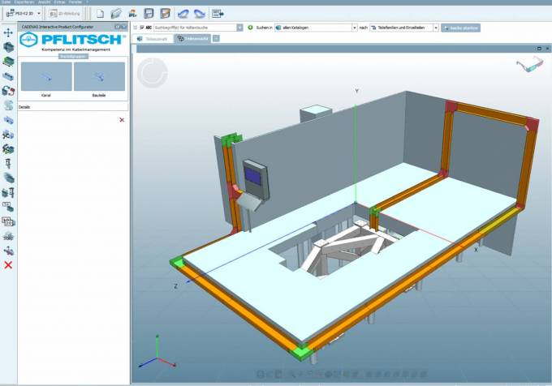
Caption 1: Following registration and activation, the planning software easyRoute can be downloaded free of charge via the PFLITSCH Club (www.pflitsch.de).

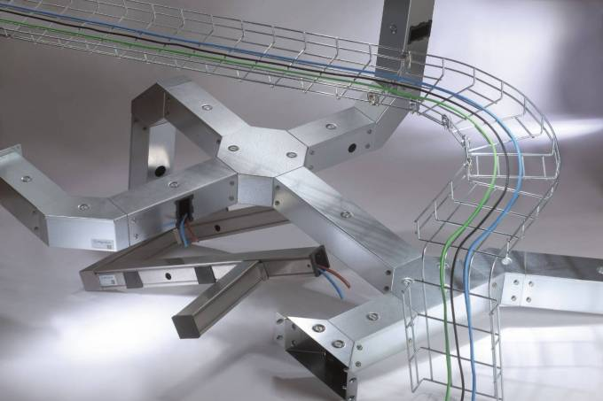
Caption 2: PFLITSCH has developed the tool easyRoute to optimize cable planning.

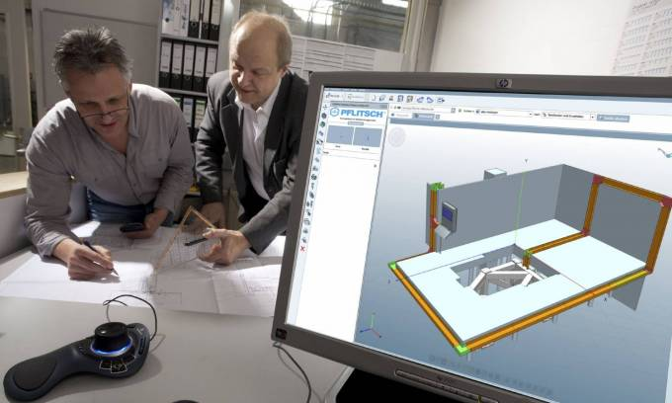
Caption 3: When planning routes, easyRoute uses a configurator with PFLITSCH components.

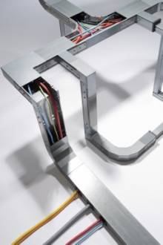
Caption 4: Planning tool “easyRoute” supports sales and the technical office of PFLITSCH.

This press release and accompanying images are available for download from our website: www.cadenas.de/press/press-releases

About CADENAS

CADENAS is a leading software developer in the areas of Strategic Parts Management and parts reduction (PARTsolutions), as well as Electronic Product Catalogs (eCATALOGsolutions). With its customized software solutions, the company acts as a link between the component manufacturers with their products and the purchasers.

With its 300 employees at 17 international subsidiaries, the name CADENAS (Spanish: process chains) has been standing for success, creativity, support and process optimization since 1992.

For further information, please visit: www.cadenas.de/en

